Ocean Uses and Marine Renewable Energy

Ben Best

2018-01-28 10:30

Table of Contents

Alaska 3

Alaska: Map of Uses 3

Alaska: Map of Depth 3

Alaska: Plot of Uses by Depth 4

Alaska: Table of Uses by Depth 4

Alaska: Map of Tide 5

Alaska: Plot of Uses by Tide 6

Alaska: Table of Uses by Tide 6

Alaska: Map of Wave 7

Alaska: Plot of Uses by Wave 7

Alaska: Table of Uses by Wave 7

Atlantic Islands 9

Atlantic Islands: Map of Uses 9

Atlantic Islands: Map of Depth 10

Atlantic Islands: Plot of Uses by Depth 10

Atlantic Islands: Table of Uses by Depth 11

Atlantic Islands: Map of Wave 11

Atlantic Islands: Plot of Uses by Wave 12

Atlantic Islands: Table of Uses by Wave 12

East 13

East: Map of Uses 13

East: Map of Depth 14

East: Plot of Uses by Depth 15

East: Table of Uses by Depth 15

East: Map of Tide 17

East: Plot of Uses by Tide 18

East: Table of Uses by Tide 18

East: Map of Wave 19

East: Plot of Uses by Wave 20

East: Table of Uses by Wave 20

East: Map of Wind 21

East: Plot of Uses by Wind 22

East: Table of Uses by Wind 22

Great Lakes 23

Great Lakes: Map of Uses 23

Great Lakes: Map of Depth 23

Great Lakes: Plot of Uses by Depth 24

Great Lakes: Table of Uses by Depth 24

Great Lakes: Map of Wind 25

Great Lakes: Plot of Uses by Wind 25

Great Lakes: Table of Uses by Wind 26

Gulf of Mexico 26

Gulf of Mexico: Map of Uses 26

Gulf of Mexico: Map of Depth 26

Gulf of Mexico: Plot of Uses by Depth 27

Gulf of Mexico: Table of Uses by Depth 27

Gulf of Mexico: Map of Tide 28

Gulf of Mexico: Plot of Uses by Tide 29

Gulf of Mexico: Table of Uses by Tide 29

Gulf of Mexico: Map of Wind 30

Gulf of Mexico: Plot of Uses by Wind 31

Gulf of Mexico: Table of Uses by Wind 31

Hawaii 32

Hawaii: Map of Uses 32

Hawaii: Map of Depth 32

Hawaii: Plot of Uses by Depth 33

Hawaii: Table of Uses by Depth 33

Hawaii: Map of Wave 35

Hawaii: Plot of Uses by Wave 36

Hawaii: Table of Uses by Wave 36

Hawaii: Map of Wind 37

Hawaii: Plot of Uses by Wind 38

Hawaii: Table of Uses by Wind 38

Pacific Islands 40

Pacific Islands: Map of Uses 40

Pacific Islands: Map of Depth 41

Pacific Islands: Plot of Uses by Depth 42

Pacific Islands: Table of Uses by Depth 42

West 43

West: Map of Uses 43

West: Map of Depth 44

West: Plot of Uses by Depth 45

West: Table of Uses by Depth 45

West: Map of Tide 48

West: Plot of Uses by Tide 49

West: Table of Uses by Tide 49

West: Map of Wave 52

West: Plot of Uses by Wave 53

West: Table of Uses by Wave 53

West: Map of Wind 56

West: Plot of Uses by Wind 57

West: Table of Uses by Wind 57

**No table of figures entries found.**  
In your document, select the words to include in the table of contents, and then on the Home tab, under Styles, click a heading style. Repeat for each heading that you want to include, and then insert the table of contents in your document. To manually create a table of contents, on the Document Elements tab, under Table of Contents, point to a style and then click the down arrow button. Click one of the styles under Manual Table of Contents, and then type the entries manually.

## Alaska

### Alaska: Map of Uses

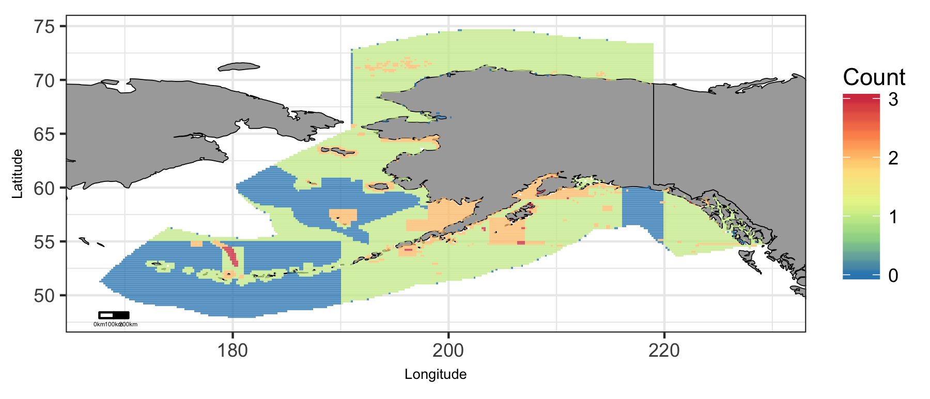

Map of cumulative ocean use in Alaska region.

### Alaska: Map of Depth

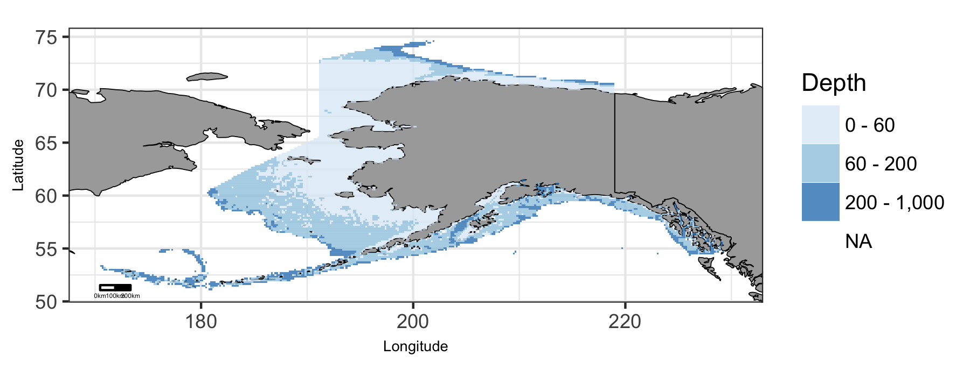

Map of viable depth in Alaska region.

### Alaska: Plot of Uses by Depth

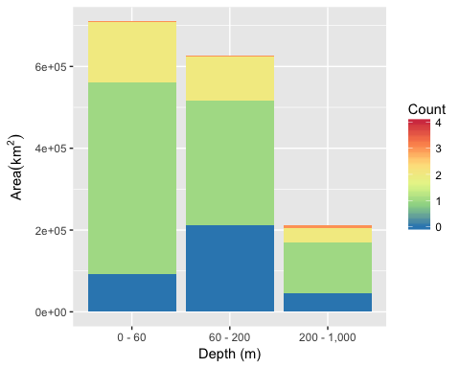

Area of Cumulative Ocean Use by Depth (m) for Alaska region. Cumulative use are counted and summarized by Depth (m) and area.

### Alaska: Table of Uses by Depth

Table 1: Area (km2) of ocean use layers by depth (m) bin for Alaska region. Layers are grouped by dataset. The total area considered was limited to maximum depth of 1000 m. The layer’s bar graph shows percent total coverage for considered area.

|  |  |  |  |  |  |  |
| --- | --- | --- | --- | --- | --- | --- |
| **Dataset**, Layer |  | % | 0 - 60 | 60 - 200 | 200 - 1,000 | Total |
| **Total Area** |  | 100 | 709,865 | 627,590 | 212,112 | 1,549,566 |
| **Active Oil & Gas Leases** |  |  |  |  |  |  |
| Active Oil & Gas Leases |  | 1 | 11,750 | 11 |  | 11,761 |
| **Aquaculture** |  |  |  |  |  |  |
| Other |  | 0 | 62 | 2 |  | 64 |
| Shellfish |  | 0 | 0 |  |  | 0 |
| **Essential Fish Habitat** |  |  |  |  |  |  |
| Bowers |  | 1 |  | 365 | 10,525 | 10,890 |
| Coral |  | 0 |  | 42 | 5 | 47 |
| Seamount |  | 0 |  |  | 517 | 517 |
| Skate |  | 0 |  | 113 | 165 | 279 |
| Slope |  | 0 | 12 | 1,248 | 4,237 | 5,497 |
| **Marine Protected Areas** |  |  |  |  |  |  |
| National Estuarine Research Reserve System |  | 0 | 530 | 252 | 11 | 794 |
| National Marine Fisheries Service |  | 75 | 609,470 | 403,506 | 150,351 | 1,163,327 |
| National Park Service |  | 0 | 806 | 913 | 341 | 2,060 |
| National Wildlife Refuge System |  | 1 | 12,543 | 1,211 | 127 | 13,881 |
| State MPA |  | 19 | 131,096 | 118,622 | 48,760 | 298,478 |
| **Shipping Lanes** |  |  |  |  |  |  |
| Shipping Lanes |  | 0 | 21 | 2,956 | 444 | 3,421 |

### Alaska: Map of Tide

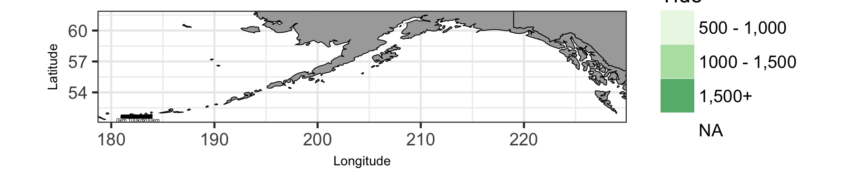

Map of viable tide in Alaska region.

### Alaska: Plot of Uses by Tide

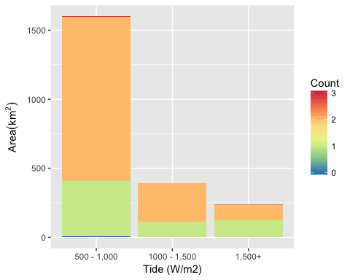

Area of Cumulative Ocean Use by Tide (W/m2) for Alaska region. Cumulative use are counted and summarized by Tide (W/m2) and area.

### Alaska: Table of Uses by Tide

Table 2: Area (km2) of ocean use layers by tide (W/m2) bin for Alaska region. Layers are grouped by dataset. The total area considered was limited to maximum depth of 100 m and minimum tide of Inf W/m2. The layer’s bar graph shows percent total coverage for considered area.

|  |  |  |  |  |  |  |
| --- | --- | --- | --- | --- | --- | --- |
| **Dataset**, Layer |  | % | 500 - 1,000 | 1000 - 1,500 | 1,500+ | Total |
| **Total Area** |  | 100 | 1,600 | 390 | 236 | 2,227 |
| **Marine Protected Areas** |  |  |  |  |  |  |
| National Marine Fisheries Service |  | 95 | 1,553 | 366 | 190 | 2,109 |
| National Park Service |  | 3 | 13 | 11 | 34 | 57 |
| National Wildlife Refuge System |  | 0 | 2 |  | 2 | 4 |
| State MPA |  | 73 | 1,219 | 288 | 123 | 1,631 |

### Alaska: Map of Wave

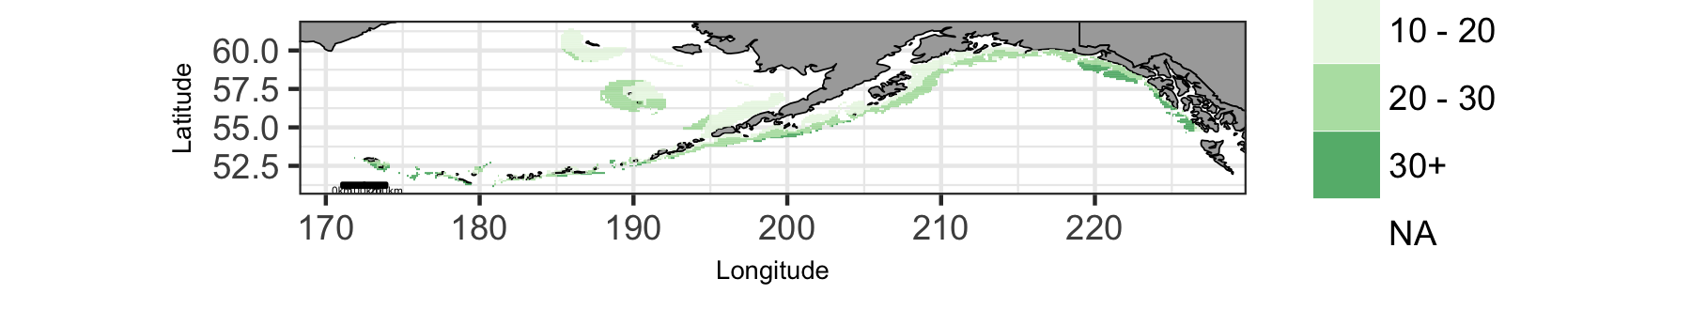

Map of viable wave in Alaska region.

### Alaska: Plot of Uses by Wave

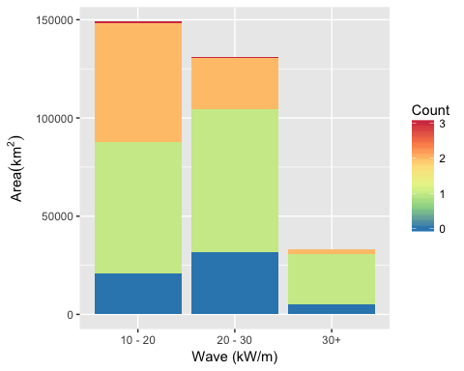

Area of Cumulative Ocean Use by Wave (kW/m) for Alaska region. Cumulative use are counted and summarized by Wave (kW/m) and area.

### Alaska: Table of Uses by Wave

Table 3: Area (km2) of ocean use layers by wave (kW/m) bin for Alaska region. Layers are grouped by dataset. The total area considered was limited to maximum depth of 200 m and minimum wave of Inf kW/m. The layer’s bar graph shows percent total coverage for considered area.

|  |  |  |  |  |  |  |
| --- | --- | --- | --- | --- | --- | --- |
| **Dataset**, Layer |  | % | 10 - 20 | 20 - 30 | 30+ | Total |
| **Total Area** |  | 100 | 148,995 | 131,201 | 33,013 | 313,209 |
| **Essential Fish Habitat** |  |  |  |  |  |  |
| Coral |  | 0 |  |  | 42 | 42 |
| Skate |  | 0 |  | 64 |  | 64 |
| Slope |  | 0 |  | 830 | 428 | 1,258 |
| **Marine Protected Areas** |  |  |  |  |  |  |
| National Marine Fisheries Service |  | 81 | 127,753 | 99,076 | 27,507 | 254,336 |
| National Park Service |  | 0 |  | 411 |  | 411 |
| National Wildlife Refuge System |  | 0 | 561 | 4 | 1 | 566 |
| State MPA |  | 28 | 60,115 | 25,651 | 2,131 | 87,897 |
| **Shipping Lanes** |  |  |  |  |  |  |
| Shipping Lanes |  | 1 | 1,557 | 1,417 |  | 2,974 |

## Atlantic Islands

### Atlantic Islands: Map of Uses

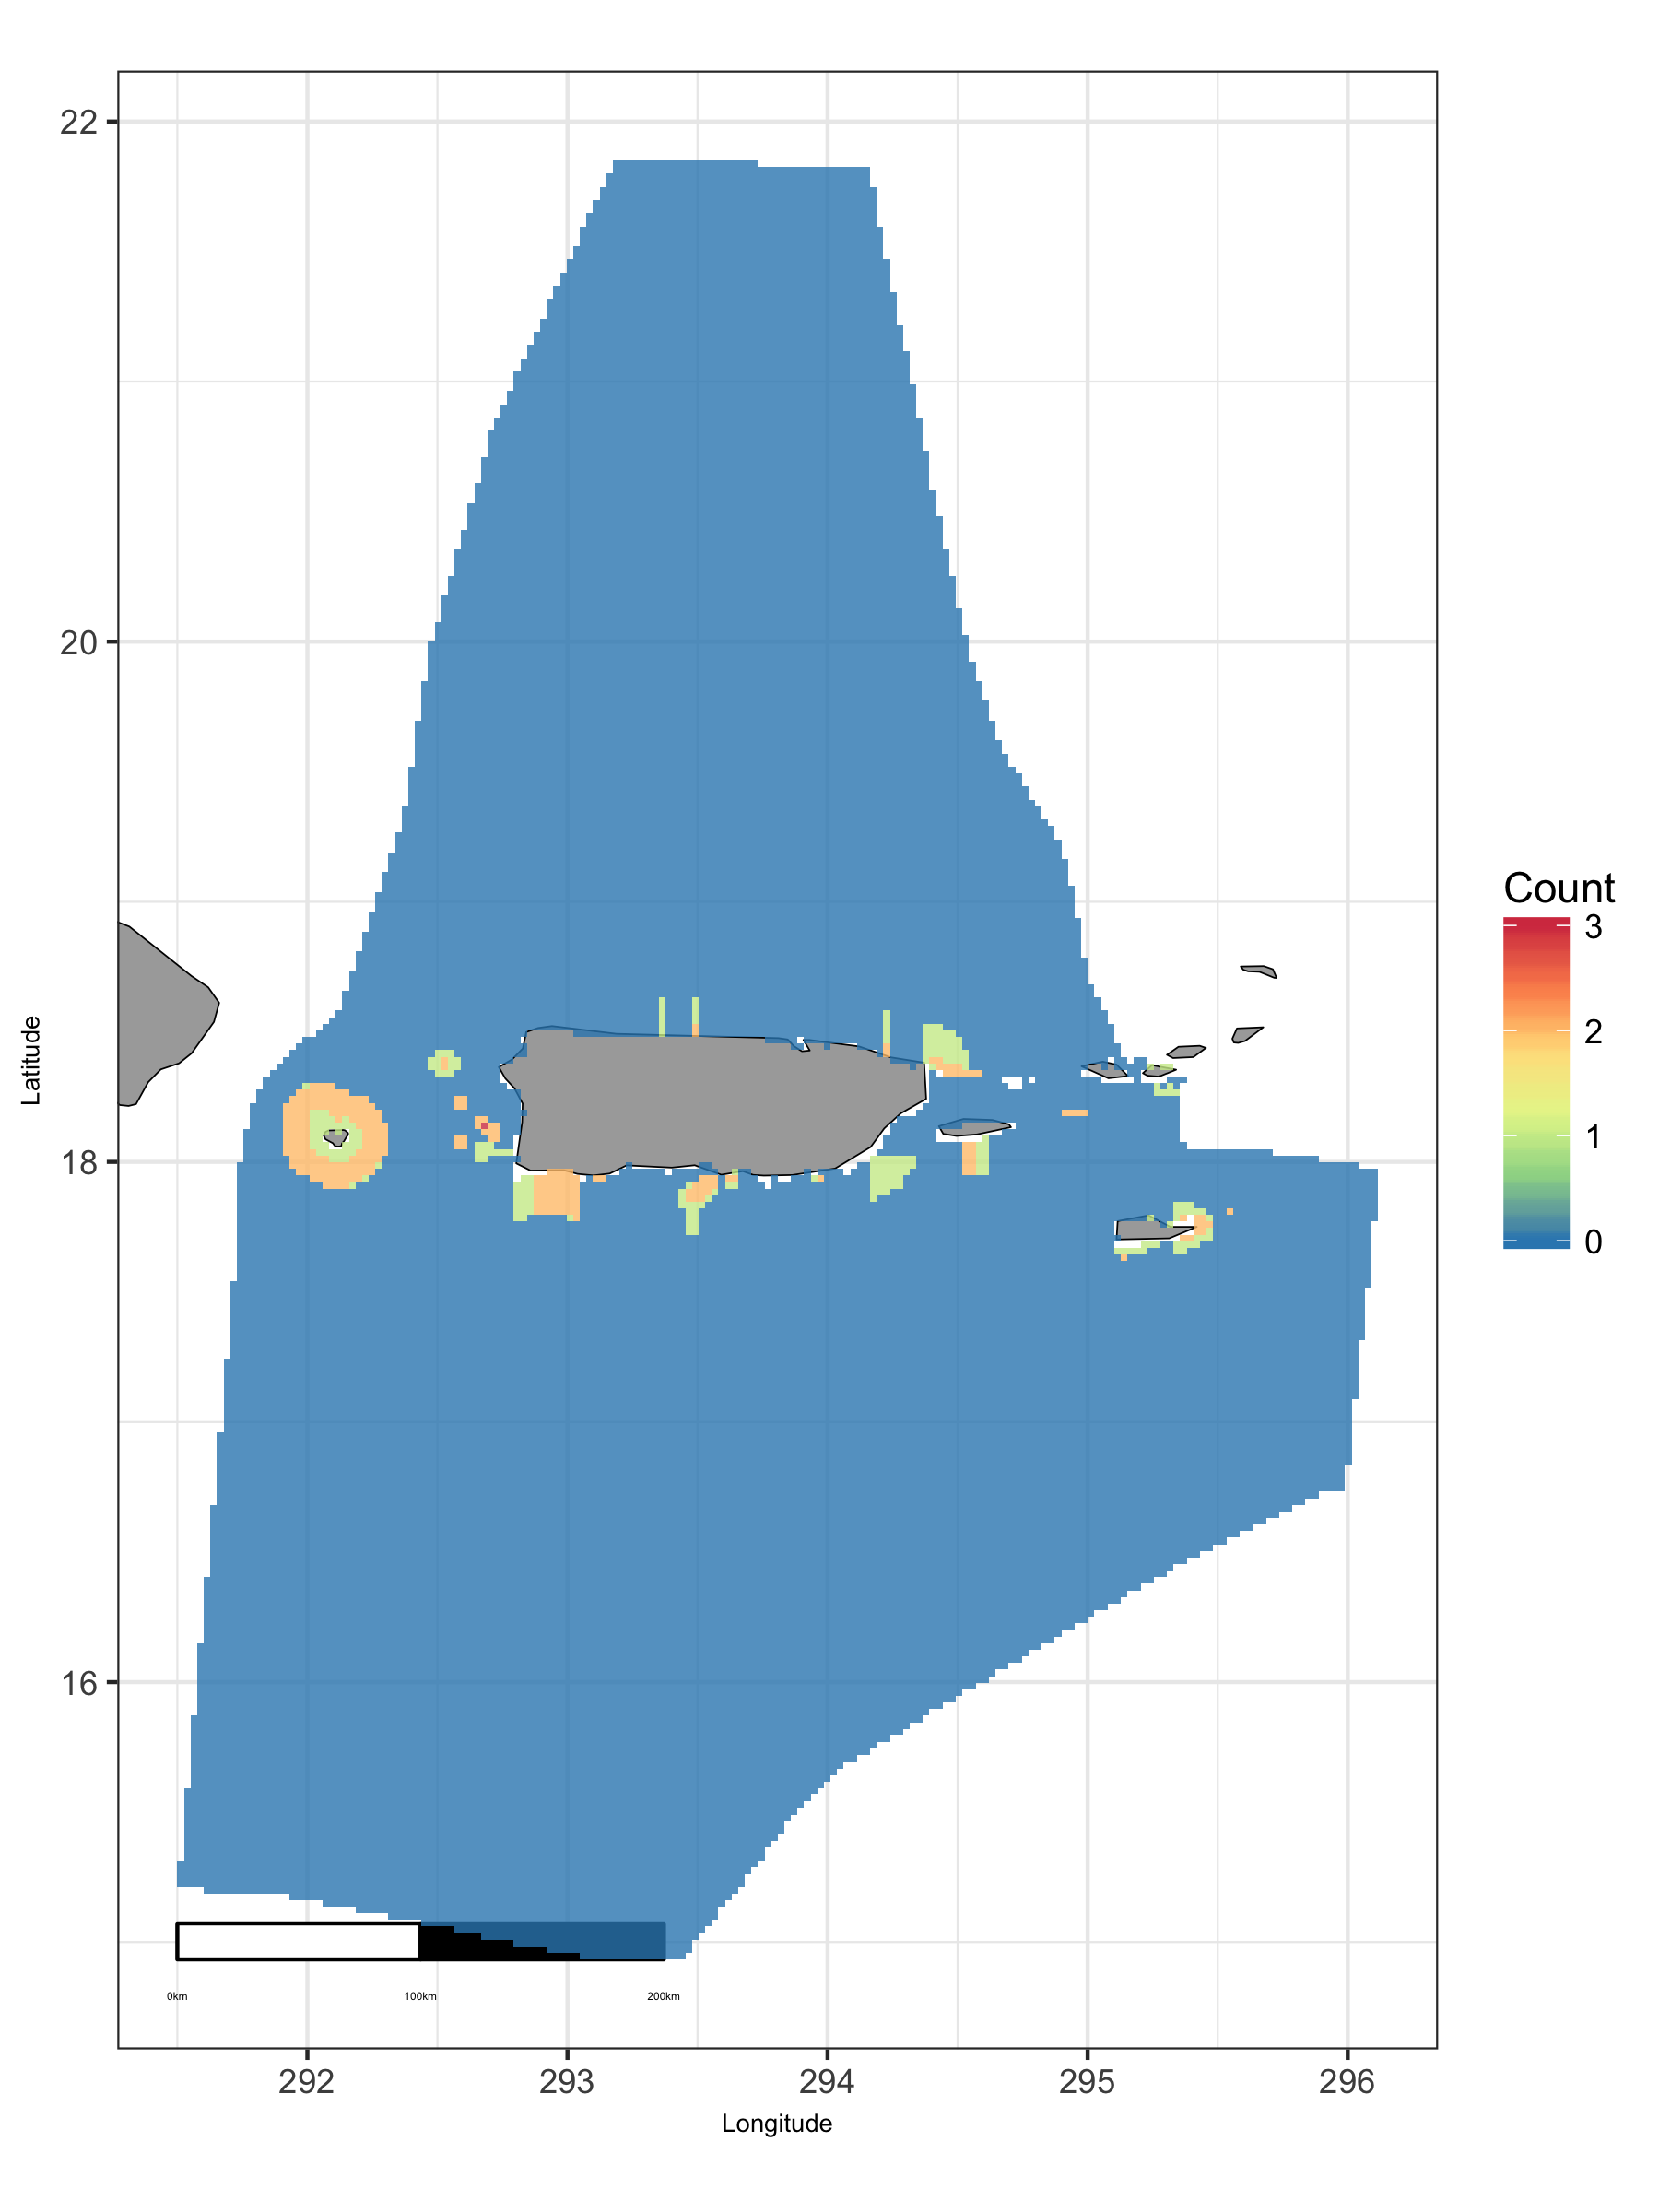

Map of cumulative ocean use in Atlantic Islands region.

### Atlantic Islands: Map of Depth

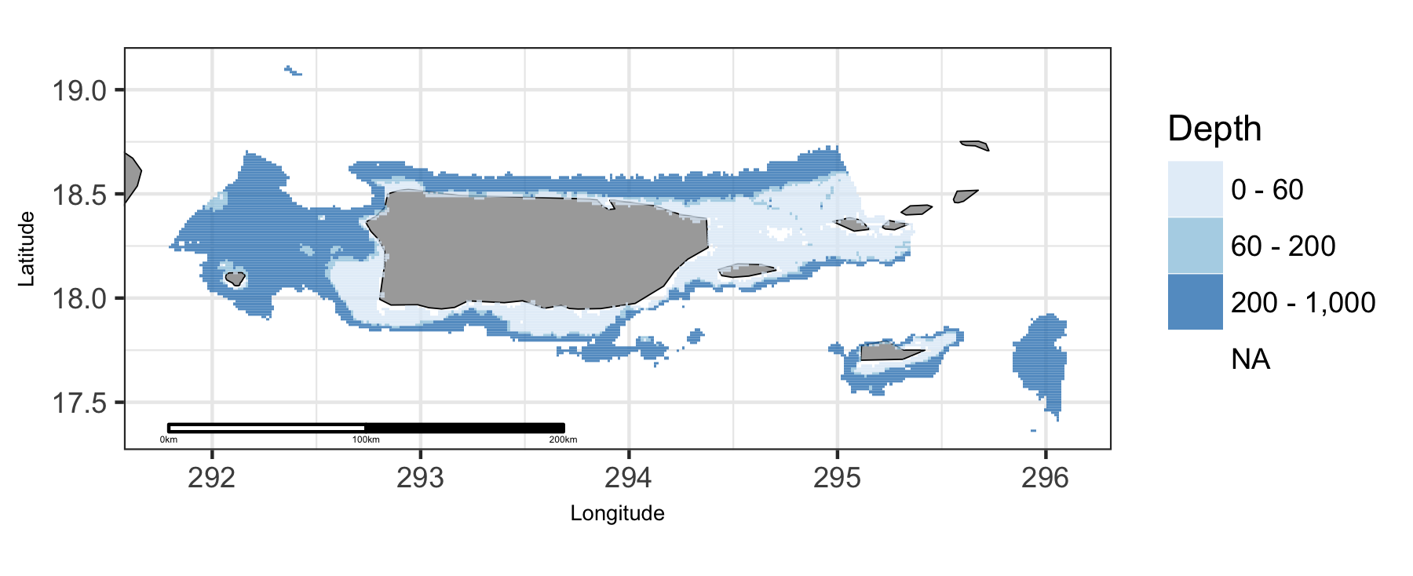

Map of viable depth in Atlantic Islands region.

### Atlantic Islands: Plot of Uses by Depth

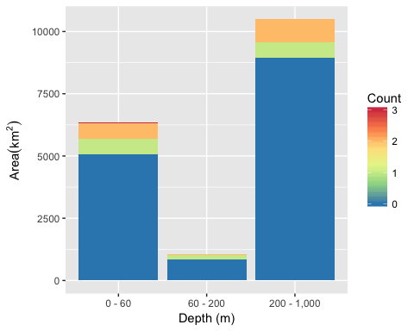

Area of Cumulative Ocean Use by Depth (m) for Atlantic Islands region. Cumulative use are counted and summarized by Depth (m) and area.

### Atlantic Islands: Table of Uses by Depth

Table 4: Area (km2) of ocean use layers by depth (m) bin for Atlantic Islands region. Layers are grouped by dataset. The total area considered was limited to maximum depth of 1000 m. The layer’s bar graph shows percent total coverage for considered area.

|  |  |  |  |  |  |  |
| --- | --- | --- | --- | --- | --- | --- |
| **Dataset**, Layer |  | % | 0 - 60 | 60 - 200 | 200 - 1,000 | Total |
| **Total Area** |  | 100 | 6,340 | 1,069 | 10,486 | 17,895 |
| **Essential Fish Habitat** |  |  |  |  |  |  |
| EFH |  | 11 | 782 | 77 | 1,045 | 1,905 |
| **Marine Protected Areas** |  |  |  |  |  |  |
| Marine National Monuments |  | 1 | 66 | 17 | 24 | 107 |
| National Estuarine Research Reserve System |  | 0 | 2 |  |  | 2 |
| National Marine Fisheries Service |  | 1 | 97 | 28 | 31 | 156 |
| National Park Service |  | 0 | 11 |  |  | 11 |
| Puerto Rico |  | 13 | 879 | 135 | 1,314 | 2,328 |
| U S Virgin Islands |  | 1 | 101 | 11 | 29 | 142 |

### Atlantic Islands: Map of Wave

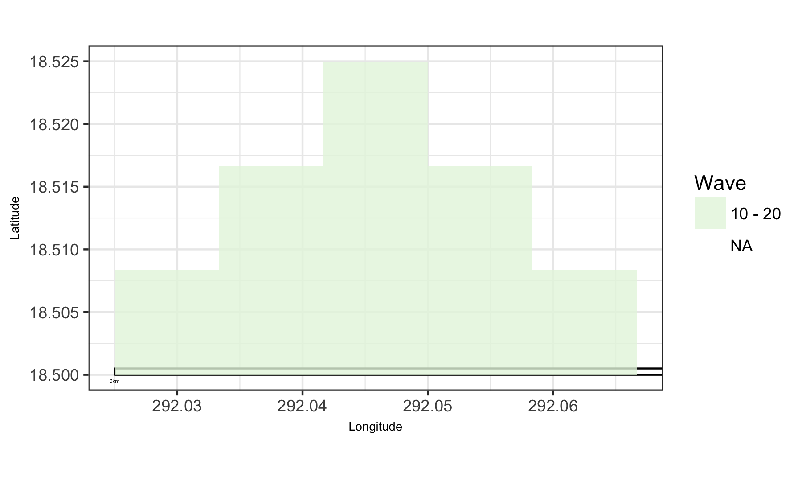

Map of viable wave in Atlantic Islands region.

### Atlantic Islands: Plot of Uses by Wave

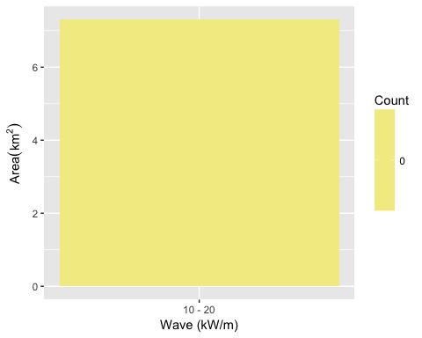

Area of Cumulative Ocean Use by Wave (kW/m) for Atlantic Islands region. Cumulative use are counted and summarized by Wave (kW/m) and area.

### Atlantic Islands: Table of Uses by Wave

Table 5: Area (km2) of ocean use layers by wave (kW/m) bin for Atlantic Islands region. Layers are grouped by dataset. The total area considered was limited to maximum depth of 200 m and minimum wave of Inf kW/m. The layer’s bar graph shows percent total coverage for considered area.

|  |  |  |  |  |
| --- | --- | --- | --- | --- |
| **Dataset**, Layer |  | % | 10 - 20 | Total |
| **Total Area** |  | 100 | 7 | 7 |

## East

### East: Map of Uses

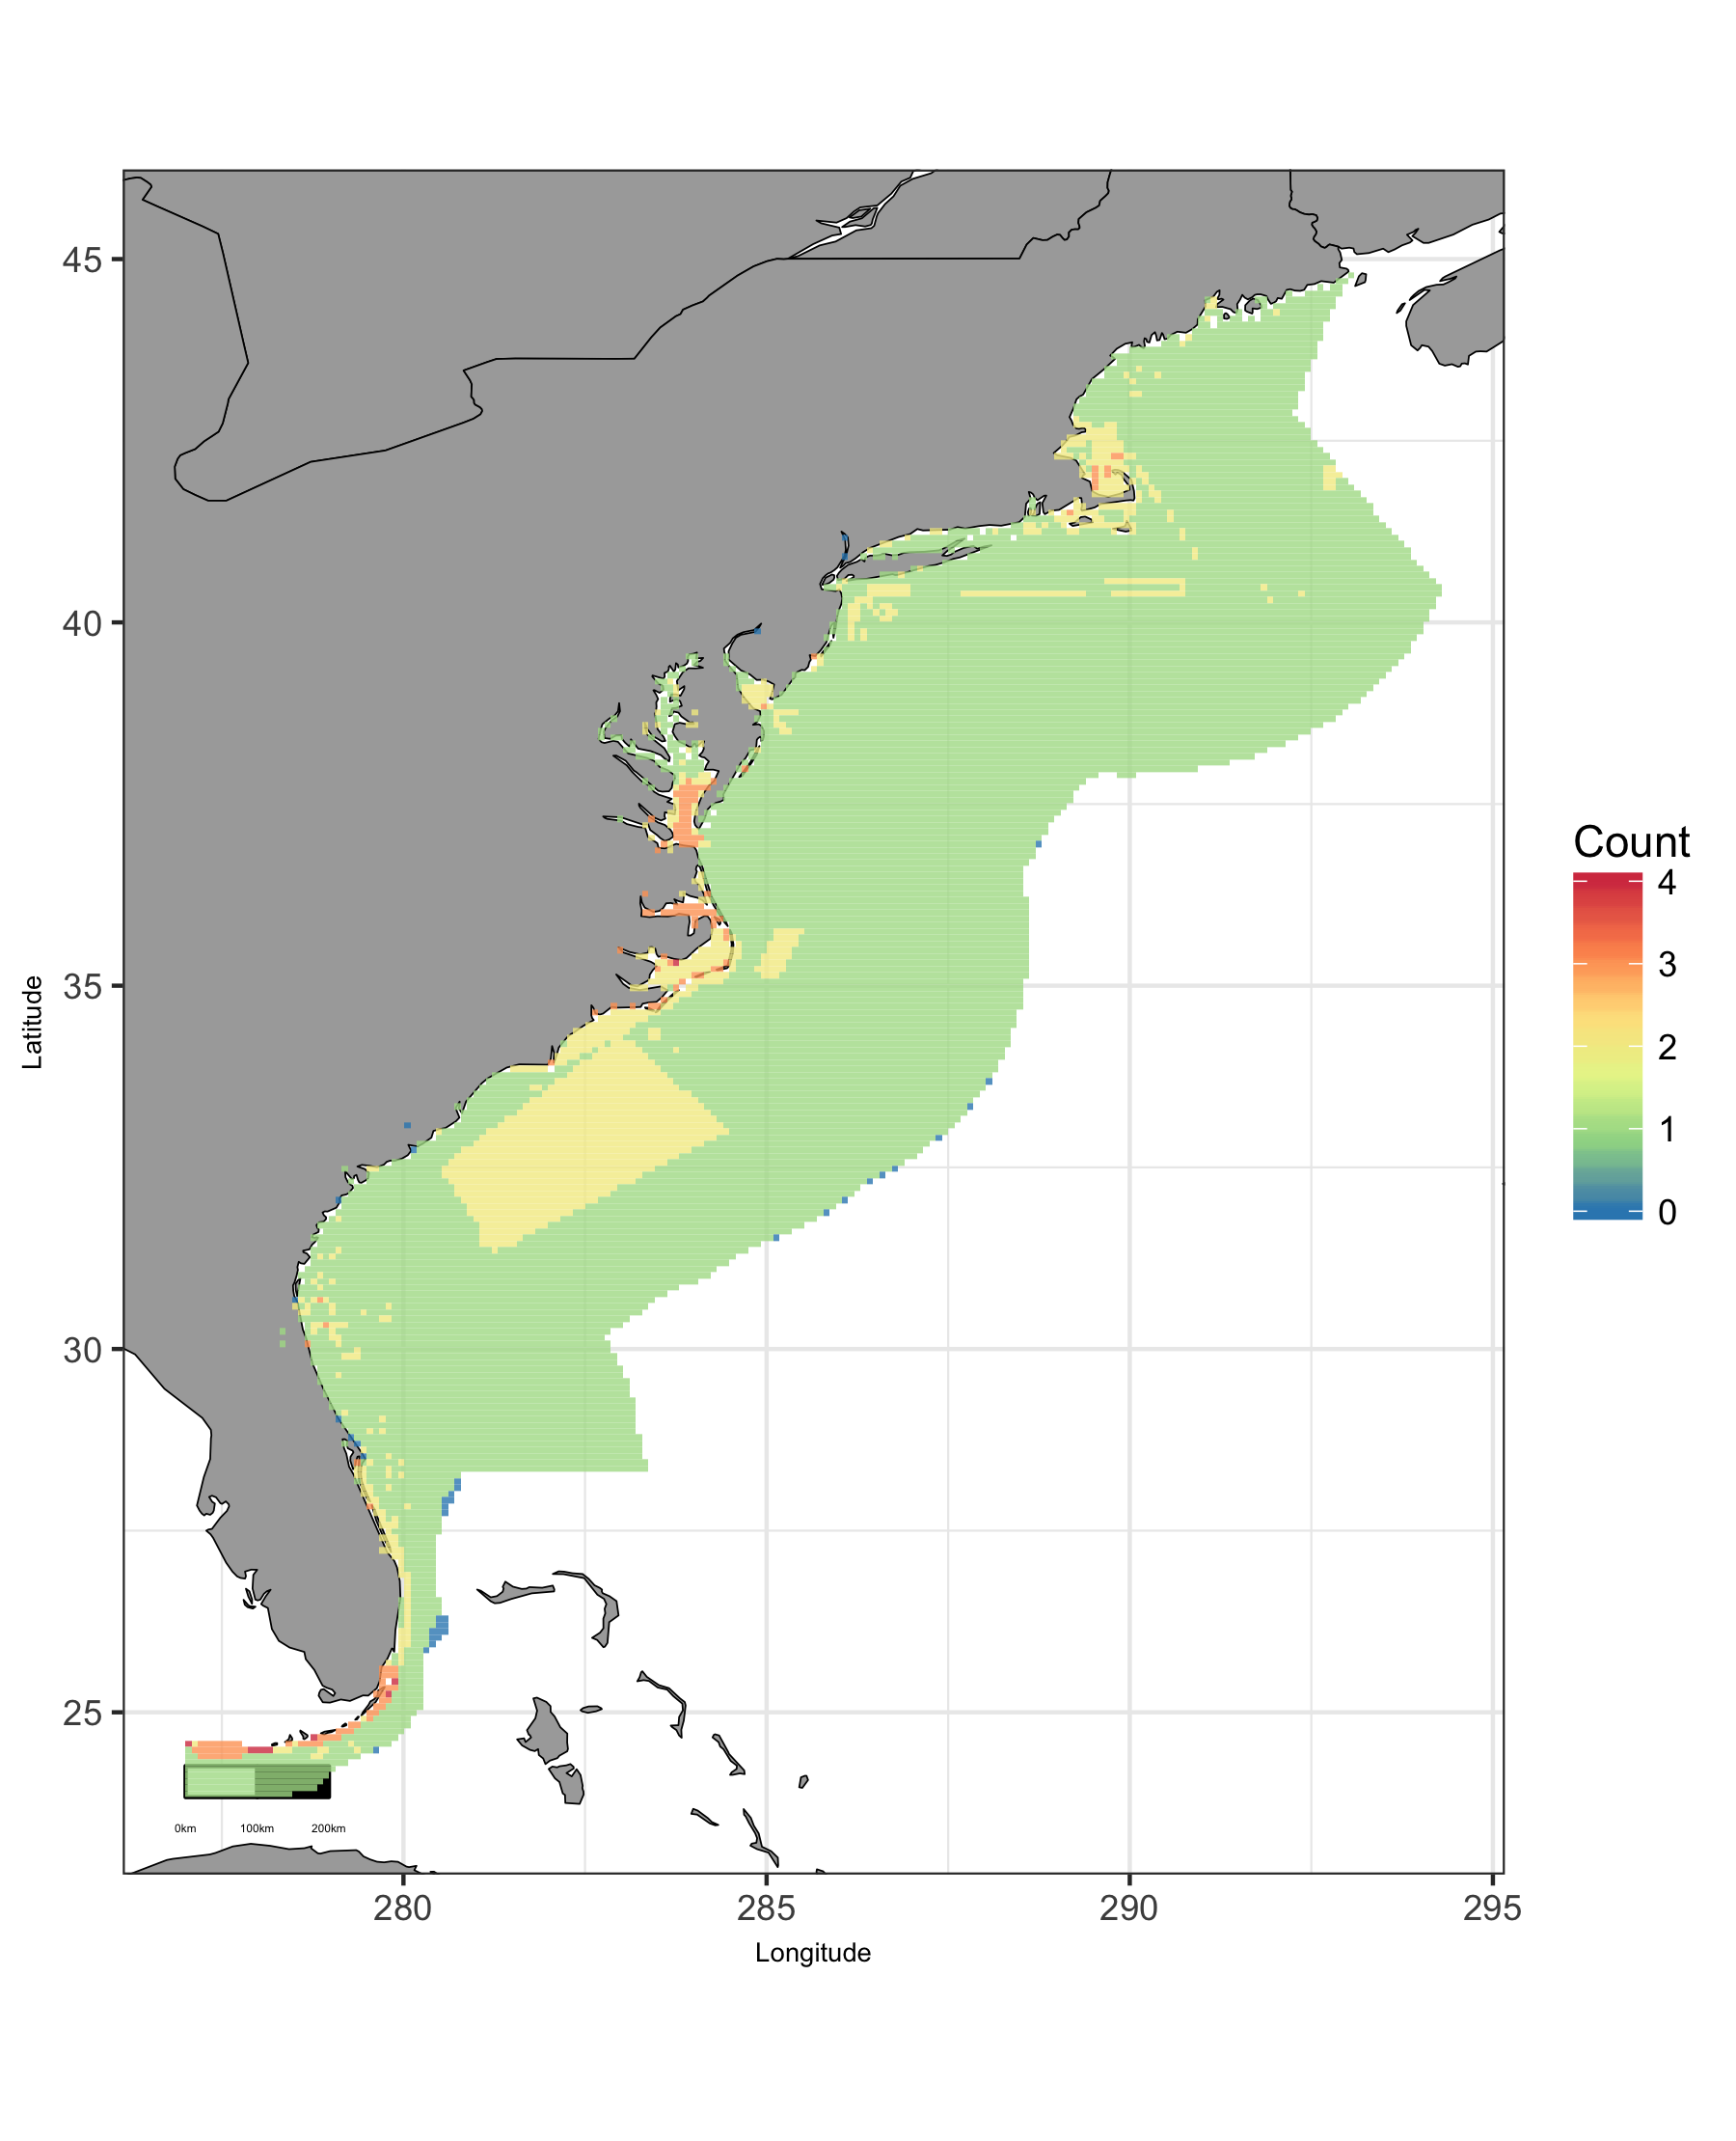

Map of cumulative ocean use in East region.

### East: Map of Depth

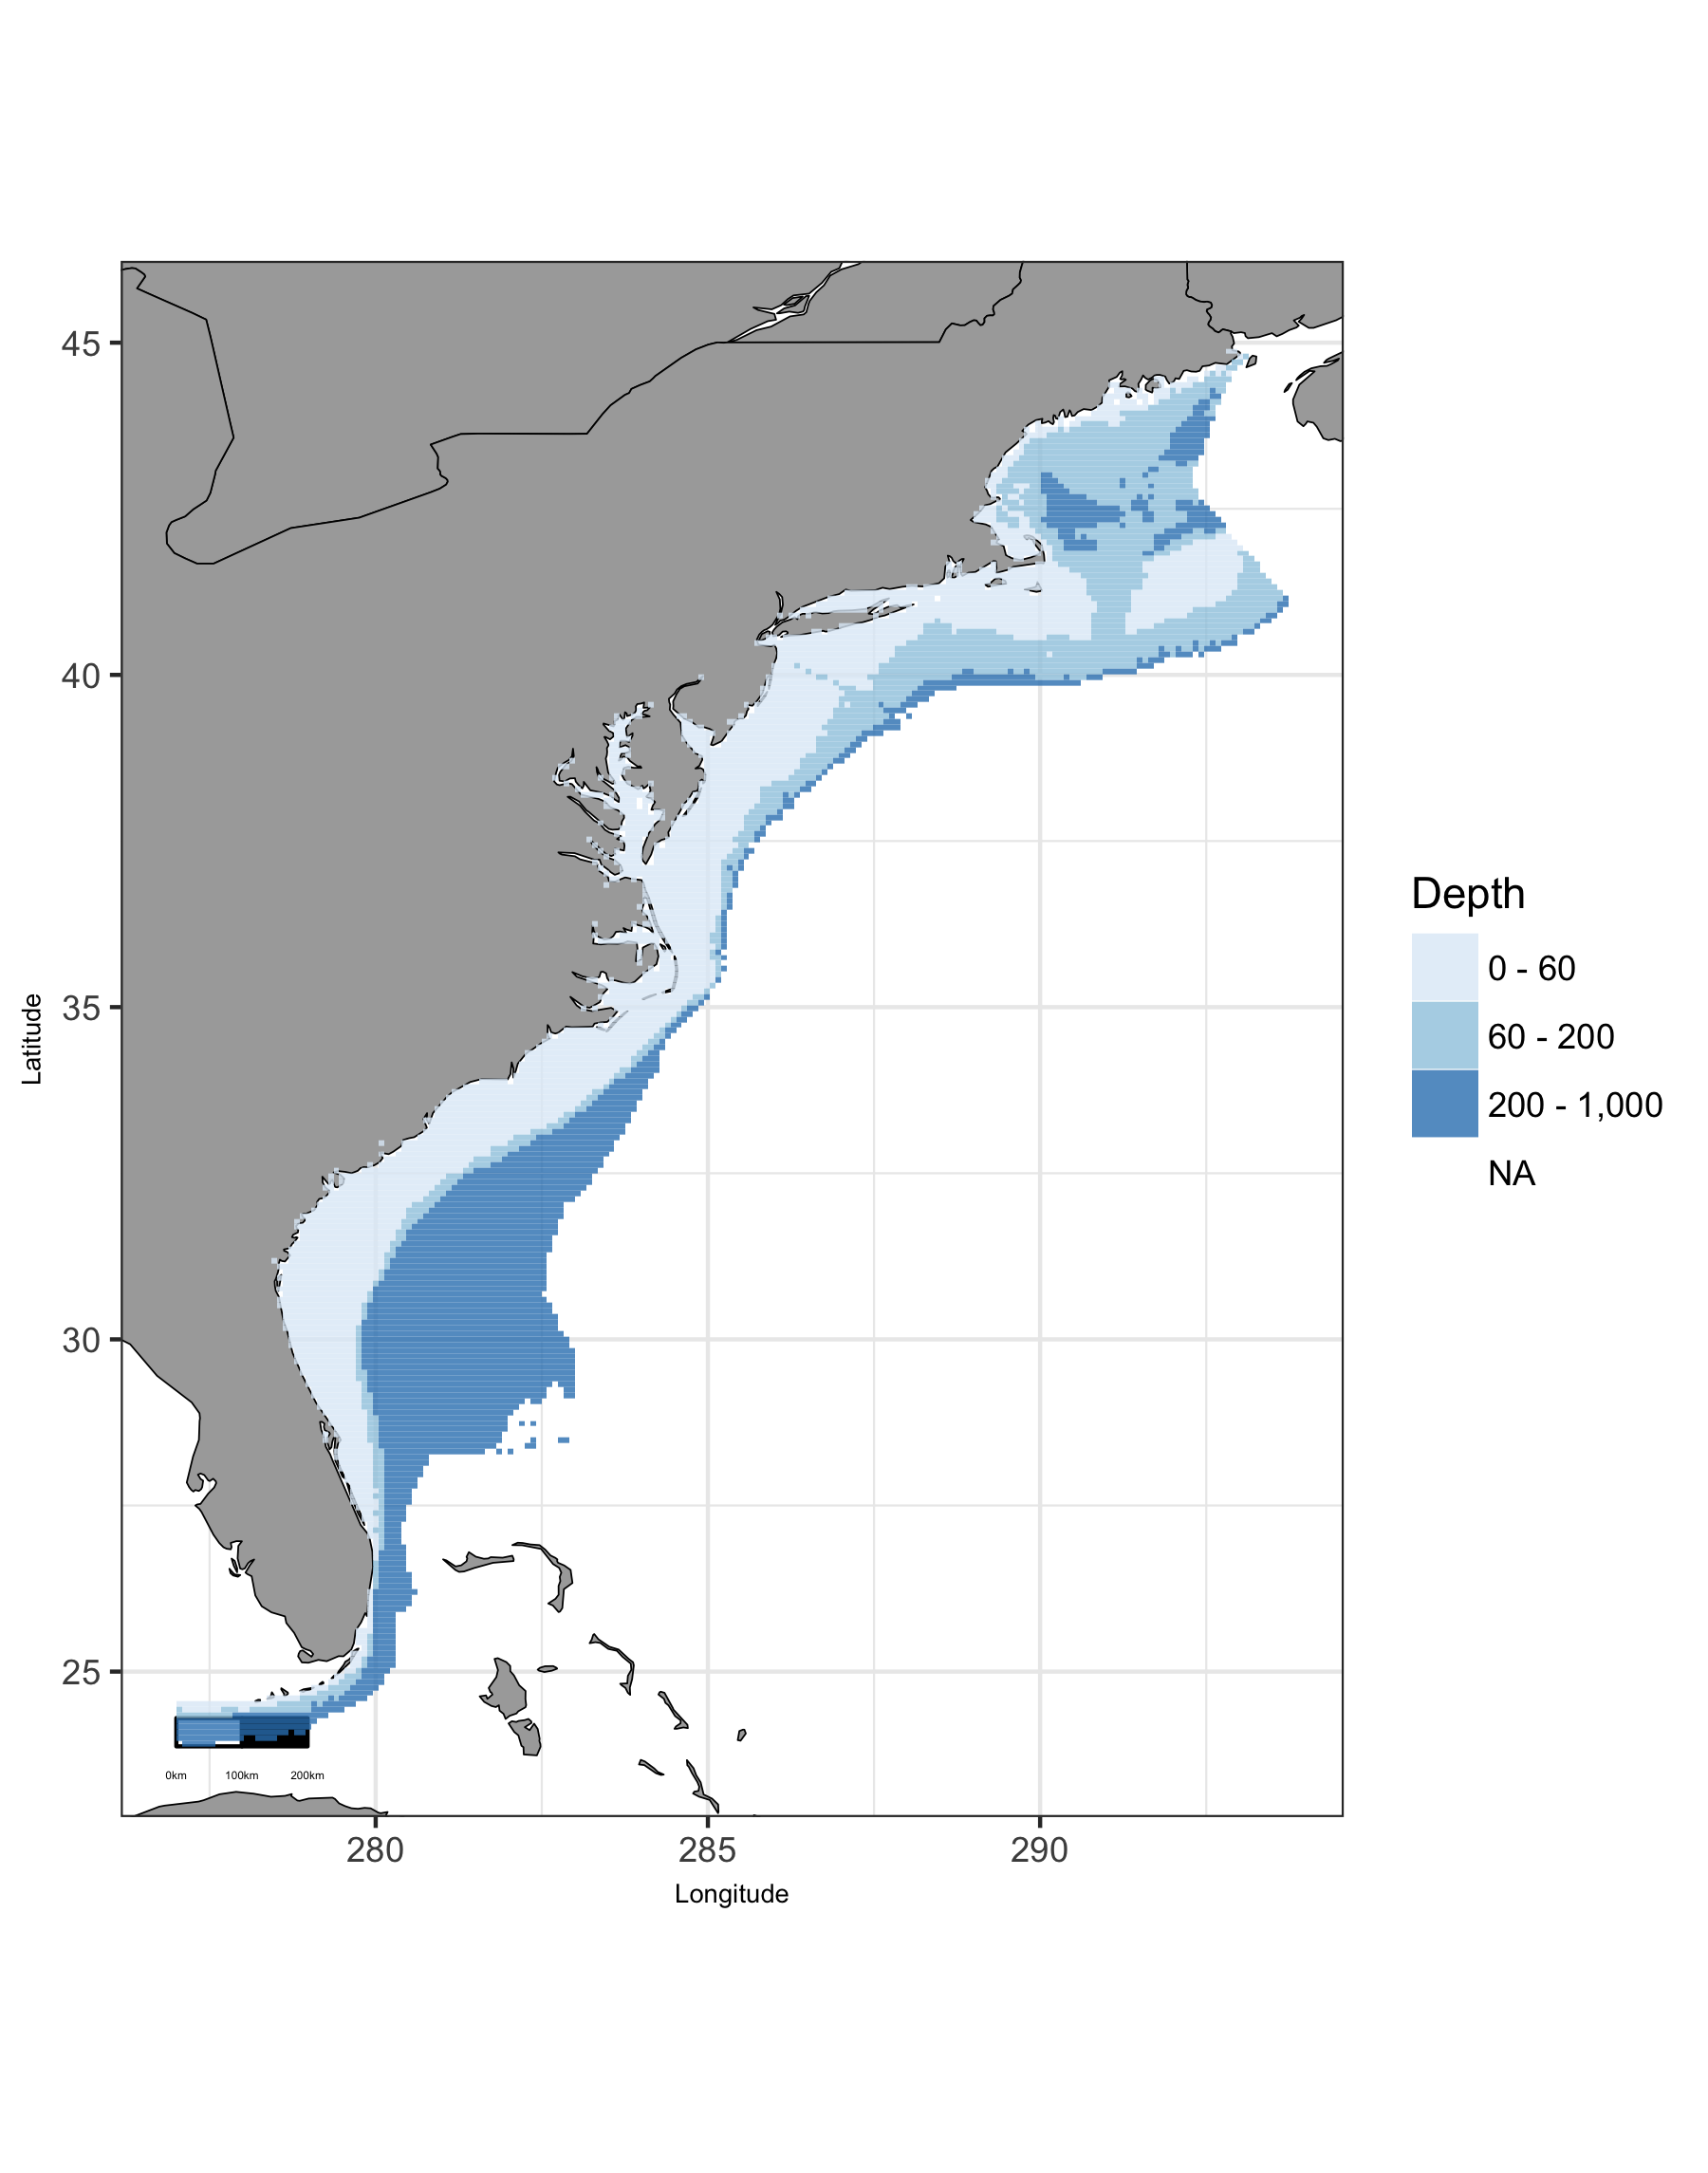

Map of viable depth in East region.

### East: Plot of Uses by Depth

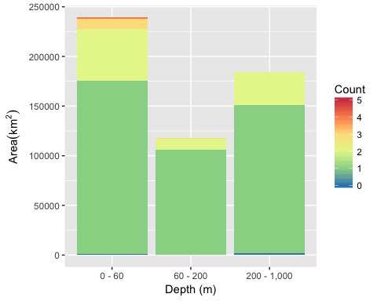

Area of Cumulative Ocean Use by Depth (m) for East region. Cumulative use are counted and summarized by Depth (m) and area.

### East: Table of Uses by Depth

Table 6: Area (km2) of ocean use layers by depth (m) bin for East region. Layers are grouped by dataset. The total area considered was limited to maximum depth of 1000 m. The layer’s bar graph shows percent total coverage for considered area.

|  |  |  |  |  |  |  |
| --- | --- | --- | --- | --- | --- | --- |
| **Dataset**, Layer |  | % | 0 - 60 | 60 - 200 | 200 - 1,000 | Total |
| **Total Area** |  | 100 | 239,101 | 118,153 | 183,838 | 541,091 |
| **Aquaculture** |  |  |  |  |  |  |
| Finfish |  | 0 | 4 |  |  | 4 |
| Other |  | 0 | 6 |  |  | 6 |
| Shellfish |  | 0 | 653 |  |  | 653 |
| **Essential Fish Habitat** |  |  |  |  |  |  |
| EFH |  | 17 | 49,636 | 7,388 | 32,497 | 89,522 |
| **Marine Protected Areas** |  |  |  |  |  |  |
| Marine National Monuments |  | 0 | 1 |  |  | 1 |
| National Estuarine Research Reserve System |  | 0 | 625 | 1 |  | 626 |
| National Marine Fisheries Service |  | 99 | 233,164 | 117,716 | 182,167 | 533,048 |
| National Marine Sanctuaries |  | 1 | 5,265 | 2,113 |  | 7,379 |
| National Park Service |  | 0 | 1,165 |  |  | 1,165 |
| National Wildlife Refuge System |  | 0 | 985 |  |  | 985 |
| State MPA |  | 3 | 16,188 | 151 |  | 16,339 |
| **Shipping Lanes** |  |  |  |  |  |  |
| Shipping Lanes |  | 2 | 6,115 | 3,734 | 4 | 9,854 |

### East: Map of Tide

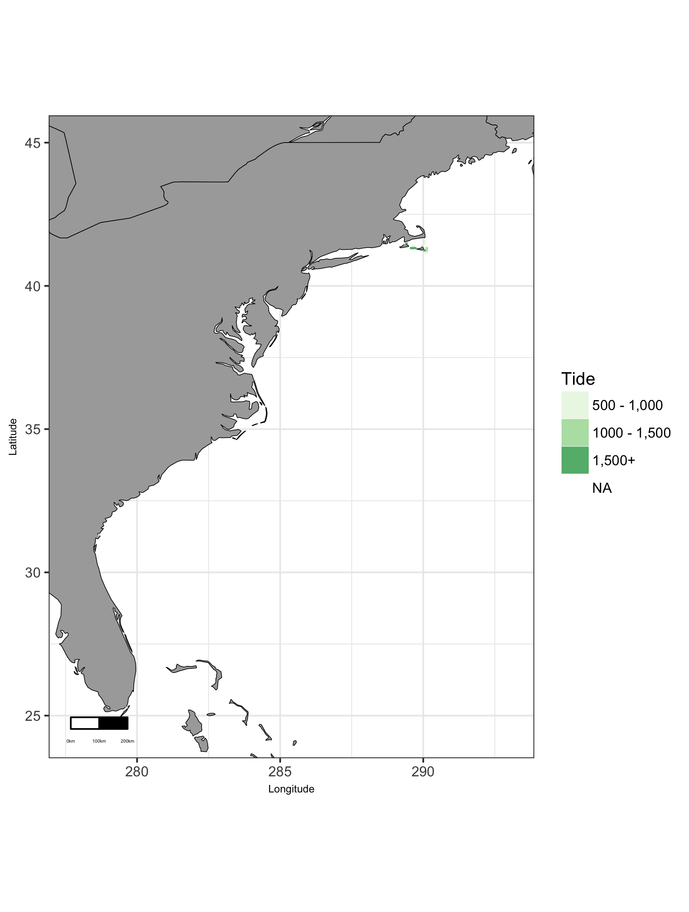

Map of viable tide in East region.

### East: Plot of Uses by Tide

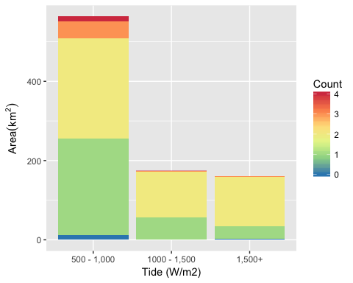

Area of Cumulative Ocean Use by Tide (W/m2) for East region. Cumulative use are counted and summarized by Tide (W/m2) and area.

### East: Table of Uses by Tide

Table 7: Area (km2) of ocean use layers by tide (W/m2) bin for East region. Layers are grouped by dataset. The total area considered was limited to maximum depth of 100 m and minimum tide of Inf W/m2. The layer’s bar graph shows percent total coverage for considered area.

|  |  |  |  |  |  |  |
| --- | --- | --- | --- | --- | --- | --- |
| **Dataset**, Layer |  | % | 500 - 1,000 | 1000 - 1,500 | 1,500+ | Total |
| **Total Area** |  | 100 | 563 | 174 | 160 | 898 |
| **Essential Fish Habitat** |  |  |  |  |  |  |
| EFH |  | 13 | 105 | 7 | 3 | 115 |
| **Marine Protected Areas** |  |  |  |  |  |  |
| National Estuarine Research Reserve System |  | 2 | 13 |  | 1 | 14 |
| National Marine Fisheries Service |  | 89 | 472 | 170 | 156 | 798 |
| National Marine Sanctuaries |  | 3 | 29 | 1 | 1 | 30 |
| National Park Service |  | 2 | 14 | 3 | 1 | 18 |
| National Wildlife Refuge System |  | 2 | 15 | 1 |  | 16 |
| State MPA |  | 58 | 279 | 113 | 125 | 517 |
| **Shipping Lanes** |  |  |  |  |  |  |
| Shipping Lanes |  | 0 | 1 |  |  | 1 |

### East: Map of Wave

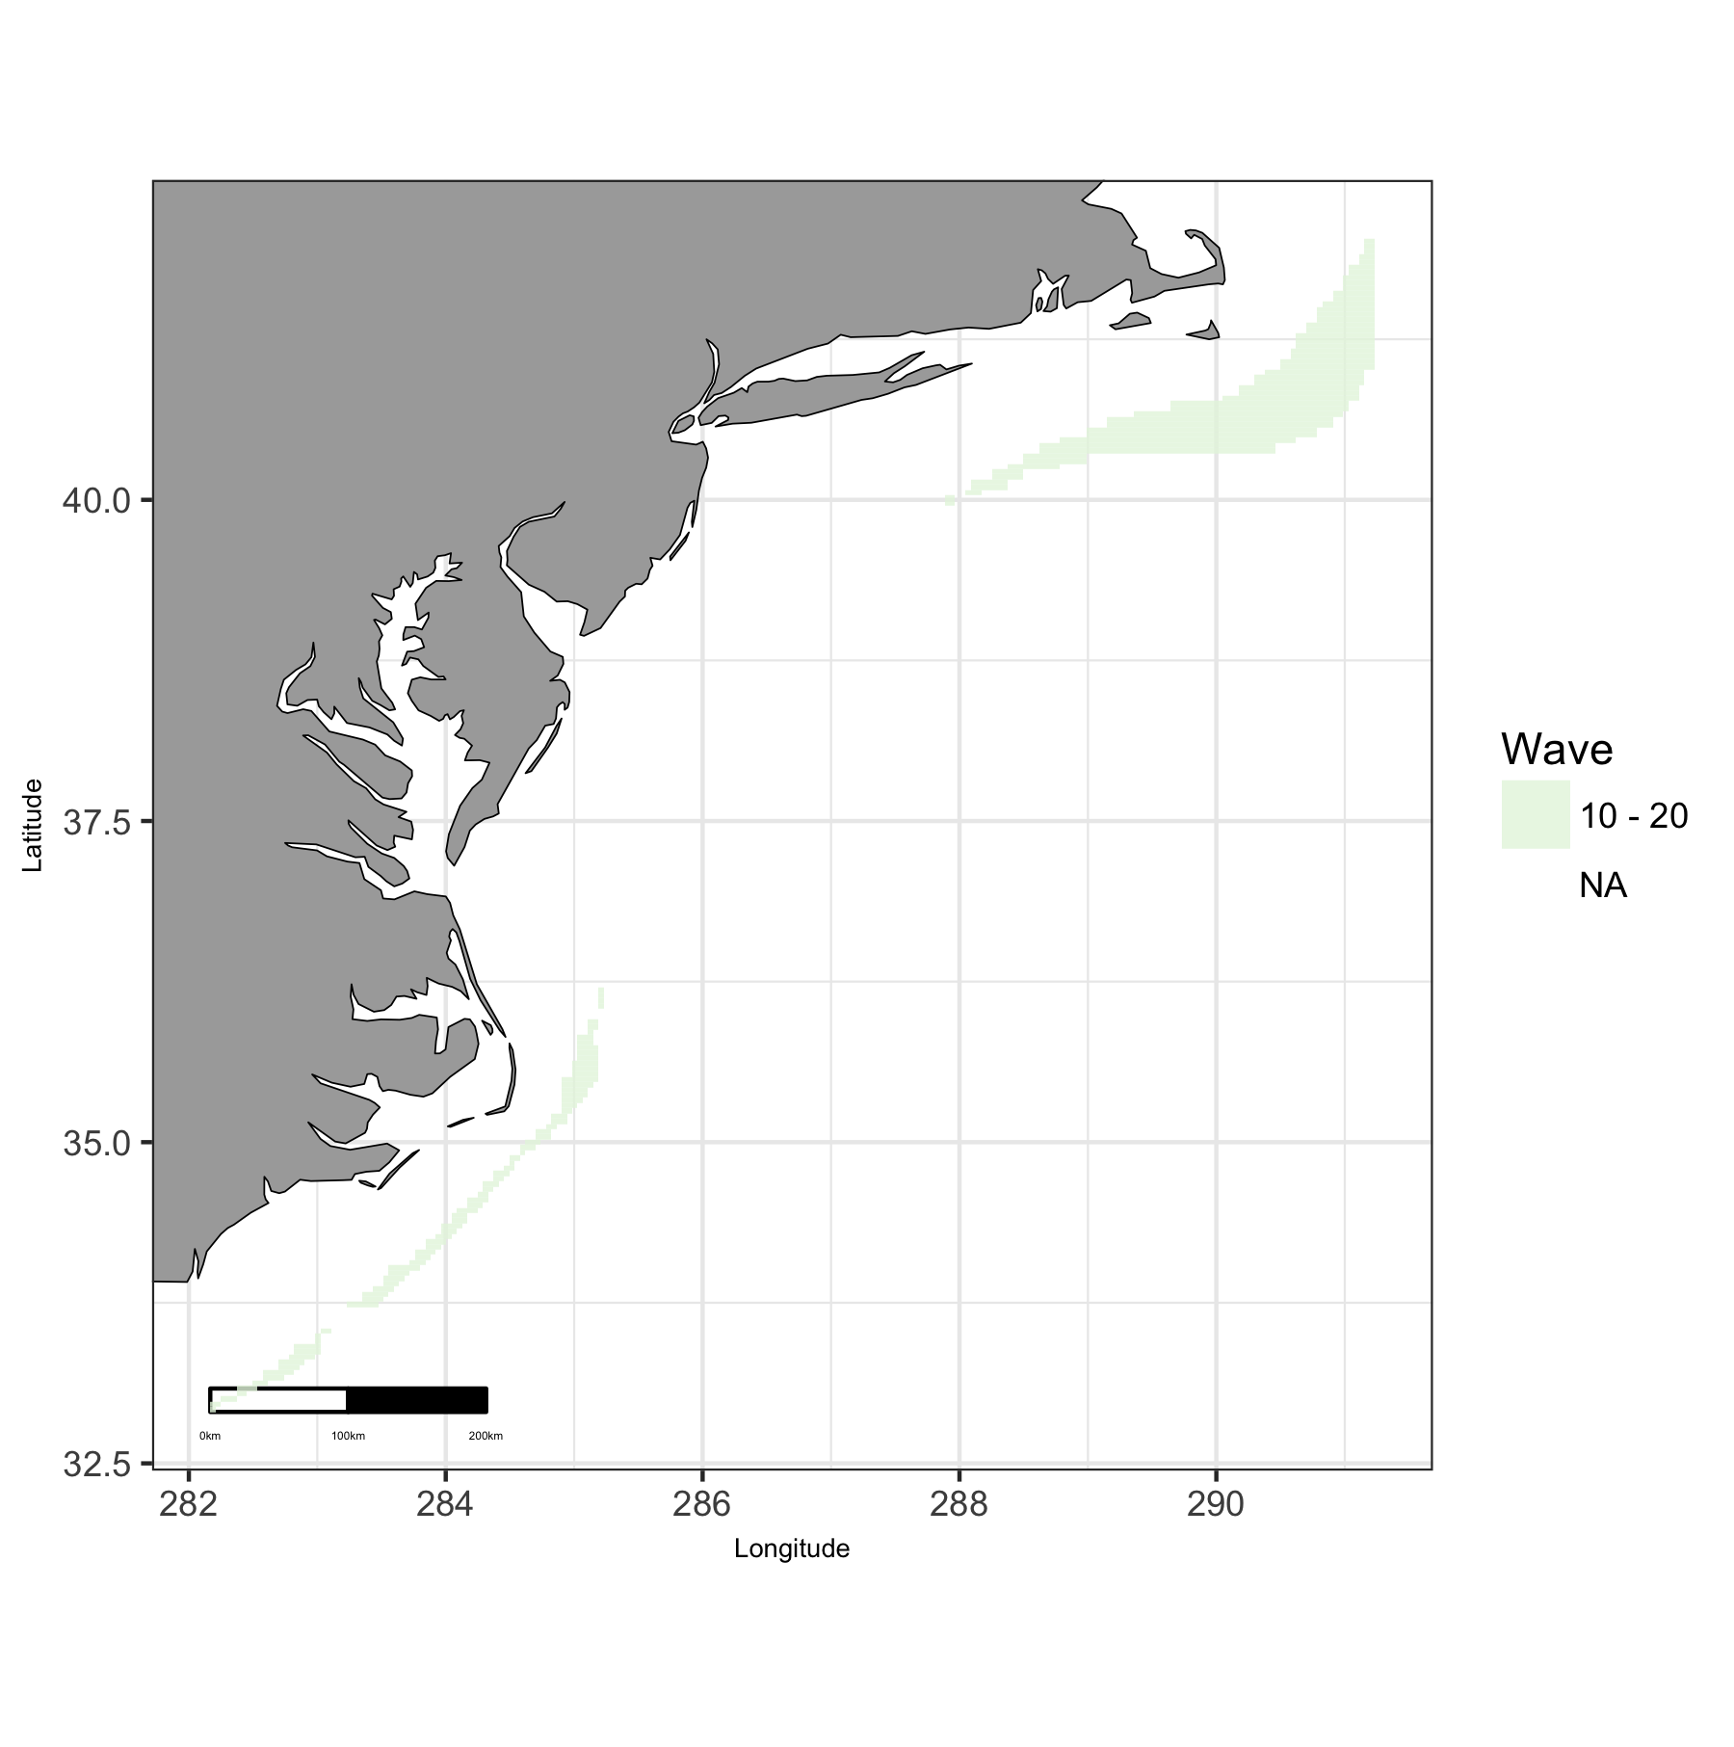

Map of viable wave in East region.

### East: Plot of Uses by Wave

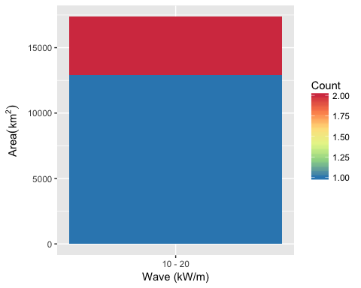

Area of Cumulative Ocean Use by Wave (kW/m) for East region. Cumulative use are counted and summarized by Wave (kW/m) and area.

### East: Table of Uses by Wave

Table 8: Area (km2) of ocean use layers by wave (kW/m) bin for East region. Layers are grouped by dataset. The total area considered was limited to maximum depth of 200 m and minimum wave of Inf kW/m. The layer’s bar graph shows percent total coverage for considered area.

|  |  |  |  |  |
| --- | --- | --- | --- | --- |
| **Dataset**, Layer |  | % | 10 - 20 | Total |
| **Total Area** |  | 100 | 17,357 | 17,357 |
| **Essential Fish Habitat** |  |  |  |  |
| EFH |  | 12 | 2,060 | 2,060 |
| **Marine Protected Areas** |  |  |  |  |
| National Marine Fisheries Service |  | 100 | 17,357 | 17,357 |
| **Shipping Lanes** |  |  |  |  |
| Shipping Lanes |  | 14 | 2,365 | 2,365 |

### East: Map of Wind

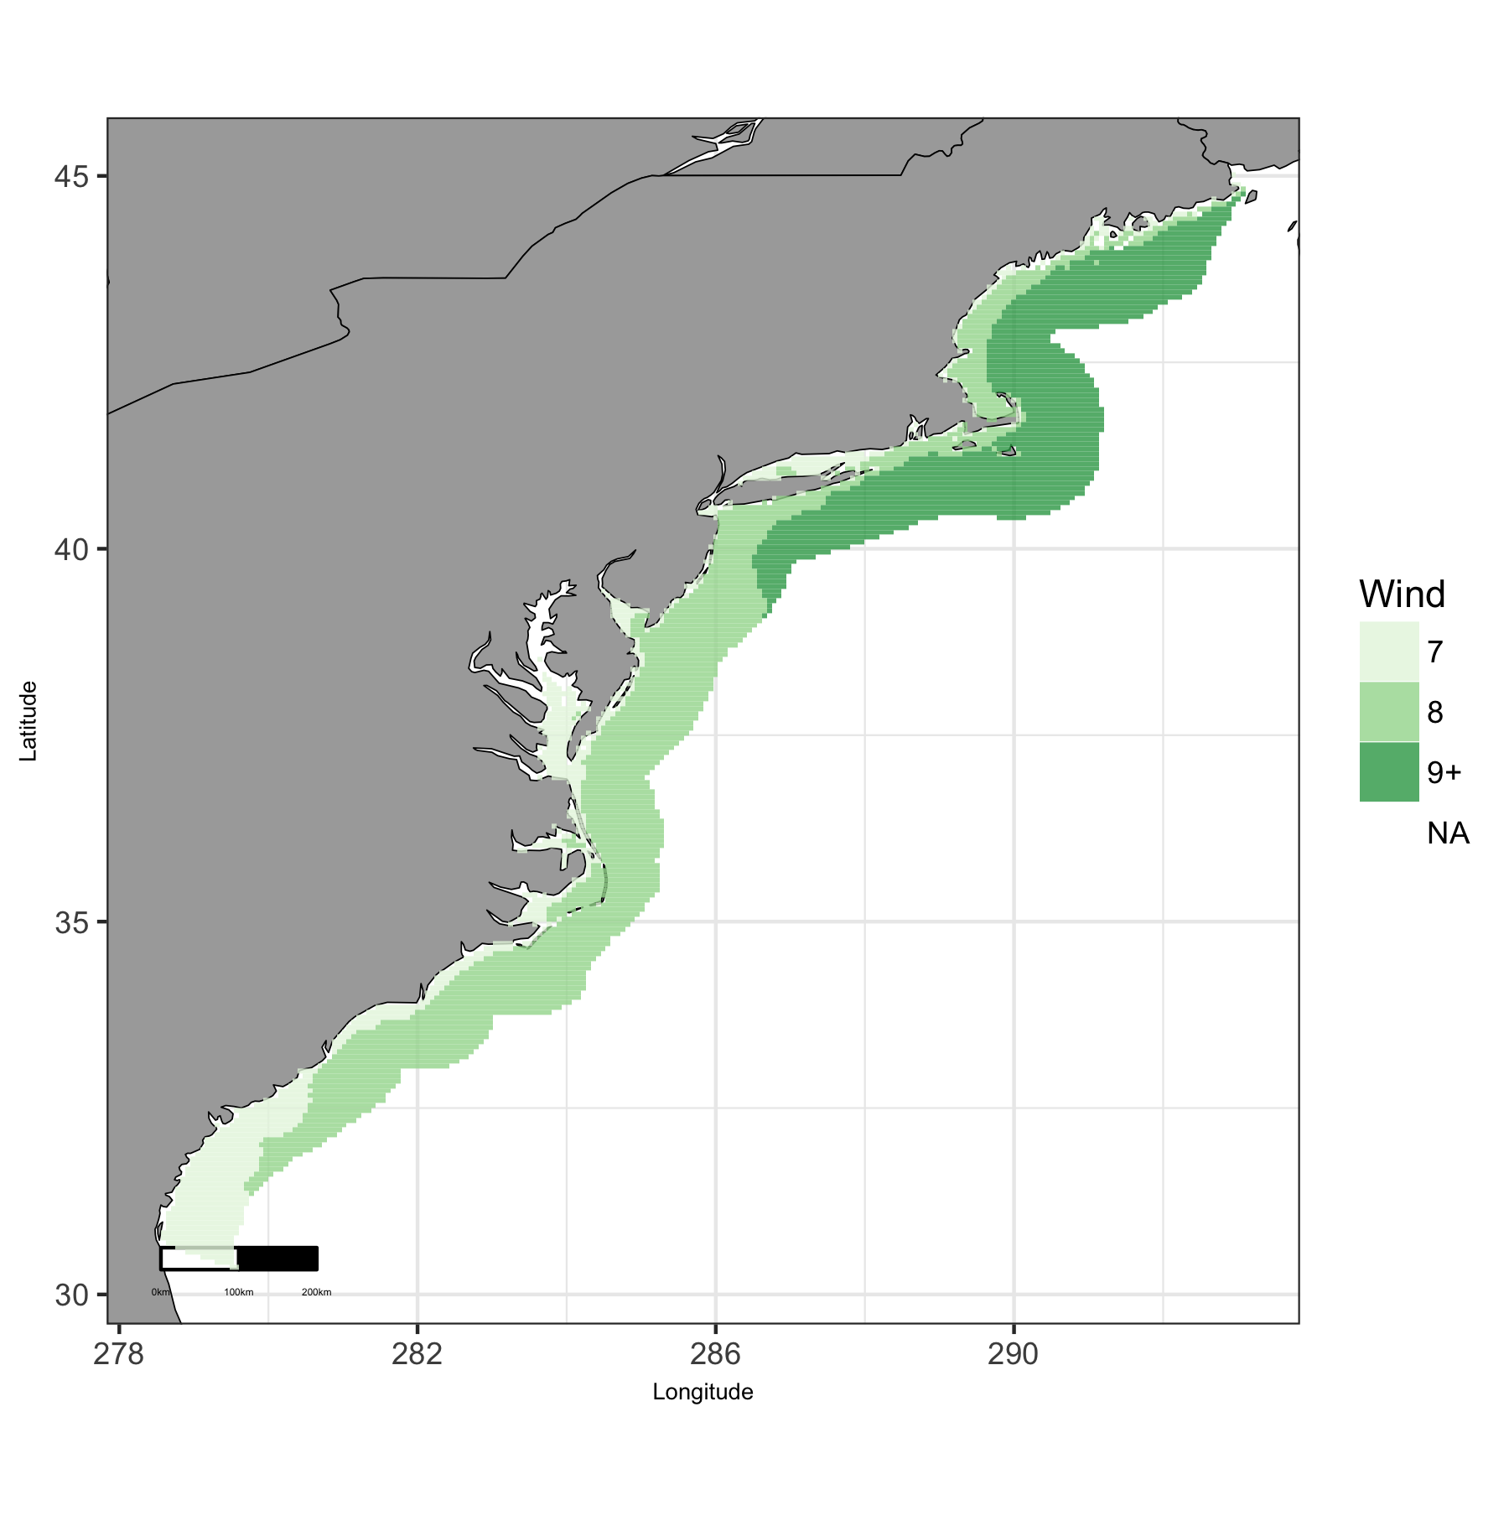

Map of viable wind in East region.

### East: Plot of Uses by Wind

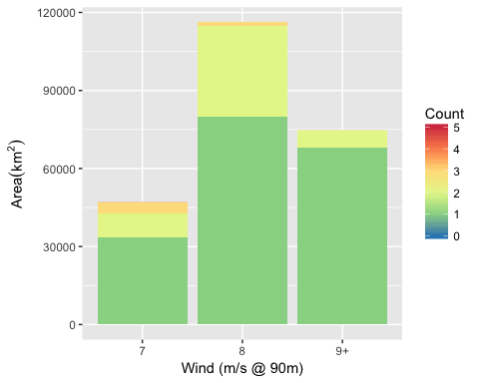

Area of Cumulative Ocean Use by Wind (m/s @ 90m) for East region. Cumulative use are counted and summarized by Wind (m/s @ 90m) and area.

### East: Table of Uses by Wind

Table 9: Area (km2) of ocean use layers by wind (m/s) bin for East region. Layers are grouped by dataset. The total area considered was limited to maximum depth of 1000 m and minimum wind of Inf m/s. The layer’s bar graph shows percent total coverage for considered area.

|  |  |  |  |  |  |  |
| --- | --- | --- | --- | --- | --- | --- |
| **Dataset**, Layer |  | % | 7 | 8 | 9+ | Total |
| **Total Area** |  | 100 | 47,050 | 116,179 | 74,625 | 237,853 |
| **Aquaculture** |  |  |  |  |  |  |
| Finfish |  | 0 | 3 |  |  | 3 |
| Other |  | 0 | 1 | 1 |  | 2 |
| Shellfish |  | 0 | 317 | 3 |  | 320 |
| **Essential Fish Habitat** |  |  |  |  |  |  |
| EFH |  | 16 | 10,820 | 28,321 |  | 39,141 |
| **Marine Protected Areas** |  |  |  |  |  |  |
| Marine National Monuments |  | 0 | 1 |  |  | 1 |
| National Estuarine Research Reserve System |  | 0 | 335 | 40 |  | 375 |
| National Marine Fisheries Service |  | 100 | 46,434 | 116,135 | 74,625 | 237,194 |
| National Marine Sanctuaries |  | 1 | 61 | 828 | 1,354 | 2,244 |
| National Park Service |  | 0 | 199 | 68 |  | 268 |
| National Wildlife Refuge System |  | 0 | 255 | 19 | 8 | 283 |
| State MPA |  | 5 | 5,640 | 5,245 | 916 | 11,801 |
| **Shipping Lanes** |  |  |  |  |  |  |
| Shipping Lanes |  | 4 | 711 | 3,338 | 4,323 | 8,372 |

## Great Lakes

### Great Lakes: Map of Uses

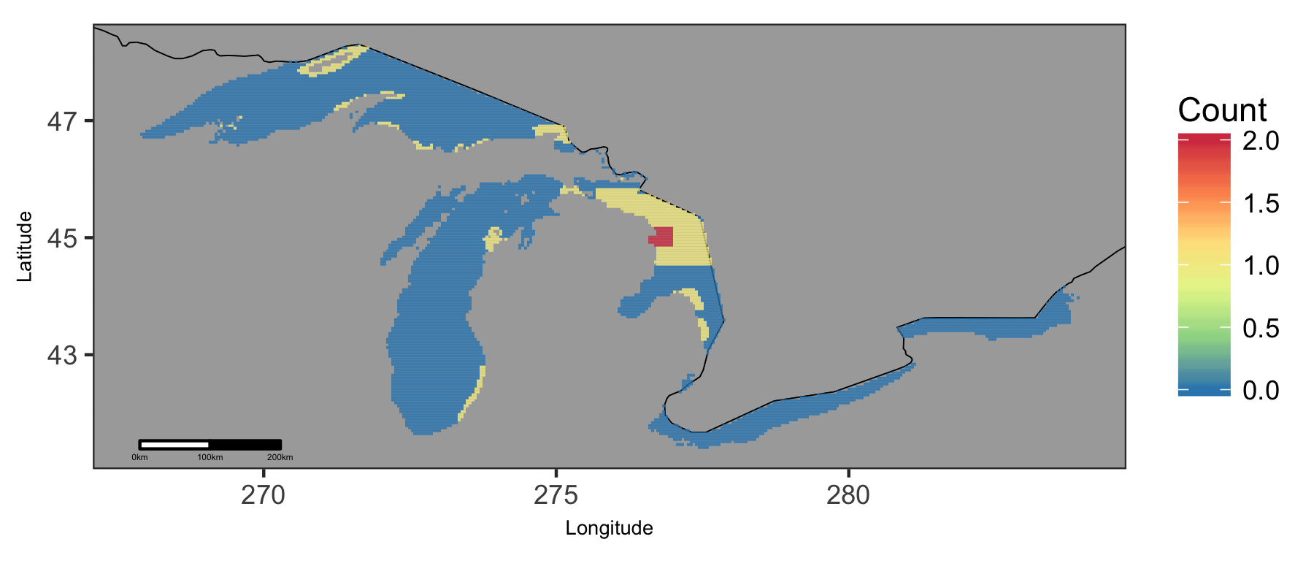

Map of cumulative ocean use in Great Lakes region.

### Great Lakes: Map of Depth

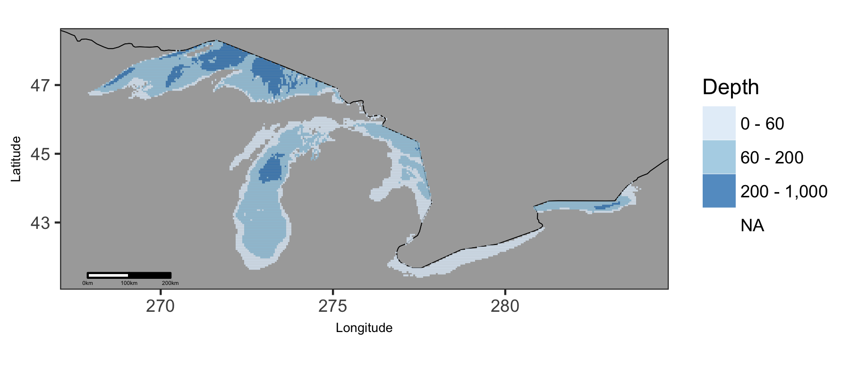

Map of viable depth in Great Lakes region.

### Great Lakes: Plot of Uses by Depth

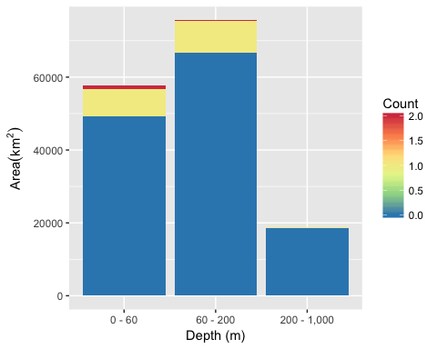

Area of Cumulative Ocean Use by Depth (m) for Great Lakes region. Cumulative use are counted and summarized by Depth (m) and area.

### Great Lakes: Table of Uses by Depth

Table 10: Area (km2) of ocean use layers by depth (m) bin for Great Lakes region. Layers are grouped by dataset. The total area considered was limited to maximum depth of 1000 m. The layer’s bar graph shows percent total coverage for considered area.

|  |  |  |  |  |  |  |
| --- | --- | --- | --- | --- | --- | --- |
| **Dataset**, Layer |  | % | 0 - 60 | 60 - 200 | 200 - 1,000 | Total |
| **Total Area** |  | 100 | 57,650 | 75,569 | 18,881 | 152,099 |
| **Marine Protected Areas** |  |  |  |  |  |  |
| National Estuarine Research Reserve System |  | 0 | 1 |  |  | 1 |
| National Marine Sanctuaries |  | 7 | 3,759 | 7,071 | 83 | 10,913 |
| National Park Service |  | 1 | 365 | 1,172 | 117 | 1,655 |
| Pennslyvania |  | 0 | 7 |  |  | 7 |
| State MPA |  | 4 | 5,160 | 760 |  | 5,920 |

### Great Lakes: Map of Wind

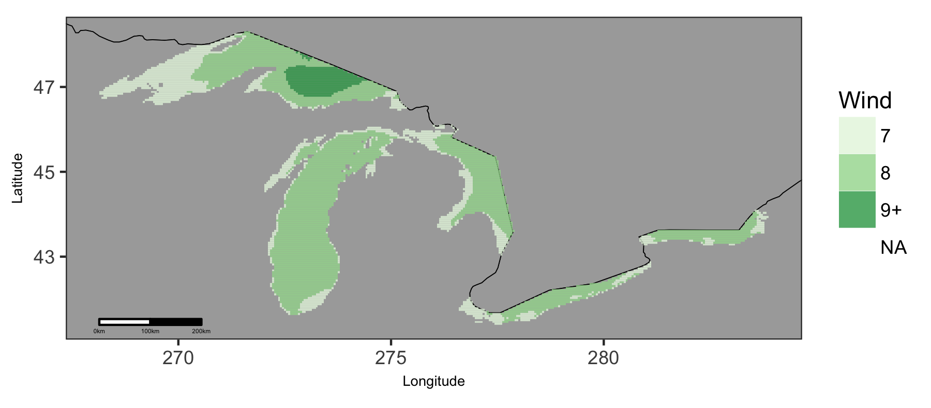

Map of viable wind in Great Lakes region.

### Great Lakes: Plot of Uses by Wind

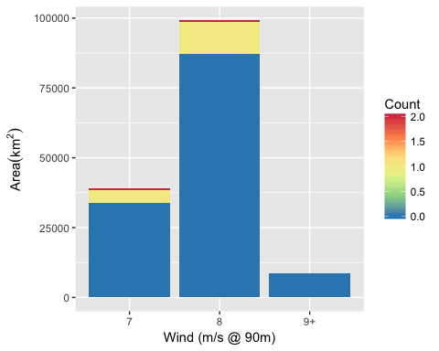

Area of Cumulative Ocean Use by Wind (m/s @ 90m) for Great Lakes region. Cumulative use are counted and summarized by Wind (m/s @ 90m) and area.

### Great Lakes: Table of Uses by Wind

Table 11: Area (km2) of ocean use layers by wind (m/s) bin for Great Lakes region. Layers are grouped by dataset. The total area considered was limited to maximum depth of 1000 m and minimum wind of Inf m/s. The layer’s bar graph shows percent total coverage for considered area.

|  |  |  |  |  |  |  |
| --- | --- | --- | --- | --- | --- | --- |
| **Dataset**, Layer |  | % | 7 | 8 | 9+ | Total |
| **Total Area** |  | 100 | 38,947 | 99,120 | 8,534 | 146,601 |
| **Marine Protected Areas** |  |  |  |  |  |  |
| National Marine Sanctuaries |  | 7 | 2,131 | 8,669 |  | 10,801 |
| National Park Service |  | 1 | 867 | 673 |  | 1,540 |
| Pennslyvania |  | 0 | 7 |  |  | 7 |
| State MPA |  | 4 | 2,712 | 3,060 |  | 5,772 |

## Gulf of Mexico

### Gulf of Mexico: Map of Uses

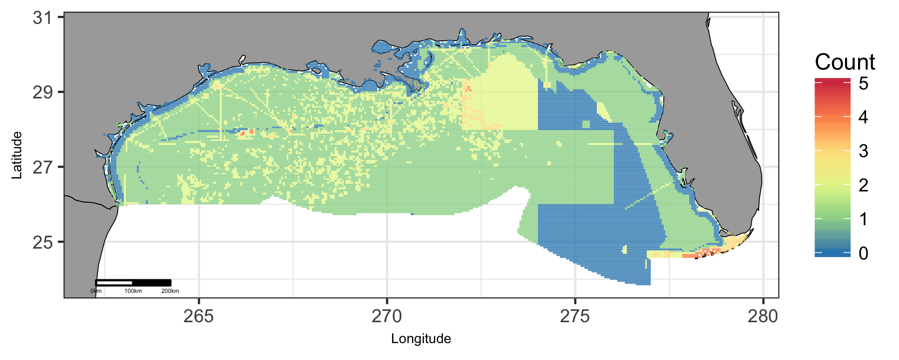

Map of cumulative ocean use in Gulf of Mexico region.

### Gulf of Mexico: Map of Depth

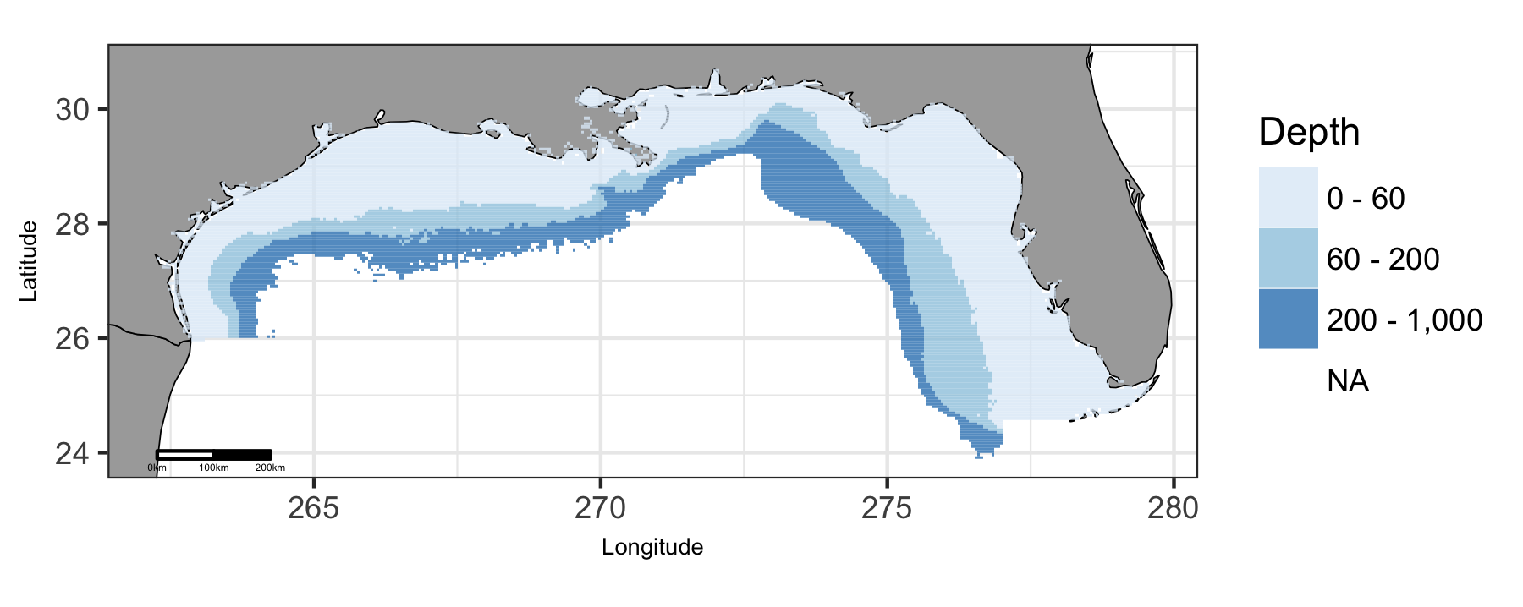

Map of viable depth in Gulf of Mexico region.

### Gulf of Mexico: Plot of Uses by Depth

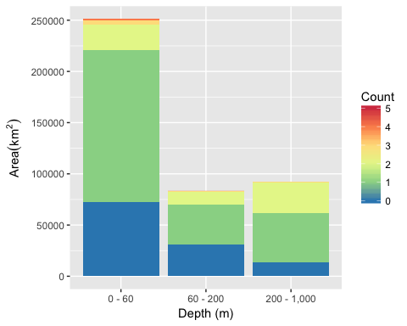

Area of Cumulative Ocean Use by Depth (m) for Gulf of Mexico region. Cumulative use are counted and summarized by Depth (m) and area.

### Gulf of Mexico: Table of Uses by Depth

Table 12: Area (km2) of ocean use layers by depth (m) bin for Gulf of Mexico region. Layers are grouped by dataset. The total area considered was limited to maximum depth of 1000 m. The layer’s bar graph shows percent total coverage for considered area.

|  |  |  |  |  |  |  |
| --- | --- | --- | --- | --- | --- | --- |
| **Dataset**, Layer |  | % | 0 - 60 | 60 - 200 | 200 - 1,000 | Total |
| **Total Area** |  | 100 | 251,128 | 83,535 | 92,050 | 426,713 |
| **Active Oil & Gas Leases** |  |  |  |  |  |  |
| Active Oil & Gas Leases |  | 6 | 12,432 | 6,239 | 8,747 | 27,418 |
| **Aquaculture** |  |  |  |  |  |  |
| Other |  | 0 | 5 |  |  | 5 |
| Shellfish |  | 0 | 13 |  |  | 13 |
| **Essential Fish Habitat** |  |  |  |  |  |  |
| EFH |  | 22 | 7,437 | 18,711 | 66,459 | 92,607 |
| **Marine Protected Areas** |  |  |  |  |  |  |
| Bureau of Ocean Energy Management |  | 1 | 437 | 1,642 | 561 | 2,640 |
| National Estuarine Research Reserve System |  | 0 | 996 |  |  | 996 |
| National Marine Fisheries Service |  | 54 | 160,632 | 38,070 | 31,435 | 230,137 |
| National Marine Sanctuaries |  | 1 | 4,283 | 201 | 55 | 4,539 |
| National Park Service |  | 1 | 2,737 |  |  | 2,737 |
| National Wildlife Refuge System |  | 1 | 2,257 | 11 |  | 2,268 |
| State MPA |  | 3 | 11,640 |  |  | 11,640 |
| **Shipping Lanes** |  |  |  |  |  |  |
| Shipping Lanes |  | 4 | 12,343 | 2,687 | 2,309 | 17,338 |

### Gulf of Mexico: Map of Tide

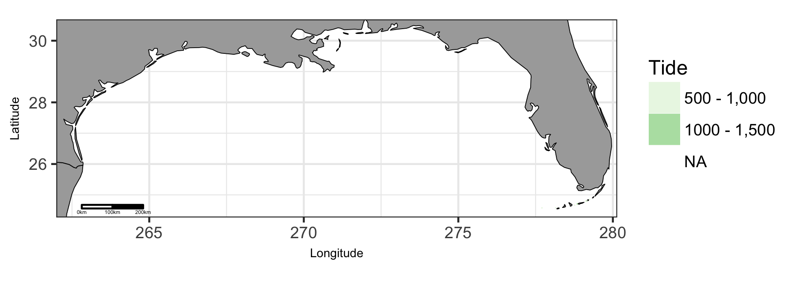

Map of viable tide in Gulf of Mexico region.

### Gulf of Mexico: Plot of Uses by Tide

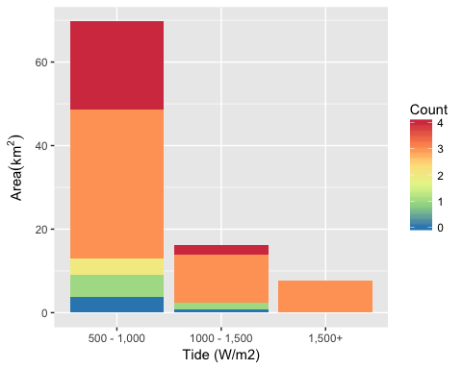

Area of Cumulative Ocean Use by Tide (W/m2) for Gulf of Mexico region. Cumulative use are counted and summarized by Tide (W/m2) and area.

### Gulf of Mexico: Table of Uses by Tide

Table 13: Area (km2) of ocean use layers by tide (W/m2) bin for Gulf of Mexico region. Layers are grouped by dataset. The total area considered was limited to maximum depth of 100 m and minimum tide of Inf W/m2. The layer’s bar graph shows percent total coverage for considered area.

|  |  |  |  |  |  |  |
| --- | --- | --- | --- | --- | --- | --- |
| **Dataset**, Layer |  | % | 500 - 1,000 | 1000 - 1,500 | 1,500+ | Total |
| **Total Area** |  | 100 | 70 | 16 | 8 | 94 |
| **Essential Fish Habitat** |  |  |  |  |  |  |
| EFH |  | 87 | 60 | 14 | 8 | 82 |
| **Marine Protected Areas** |  |  |  |  |  |  |
| National Marine Fisheries Service |  | 2 | 2 |  |  | 2 |
| National Marine Sanctuaries |  | 87 | 60 | 14 | 8 | 82 |
| National Park Service |  | 1 | 1 |  |  | 1 |
| National Wildlife Refuge System |  | 27 | 23 | 2 |  | 25 |
| State MPA |  | 86 | 58 | 15 | 8 | 81 |
| **Shipping Lanes** |  |  |  |  |  |  |
| Shipping Lanes |  | 2 | 2 | 1 |  | 2 |

### Gulf of Mexico: Map of Wind

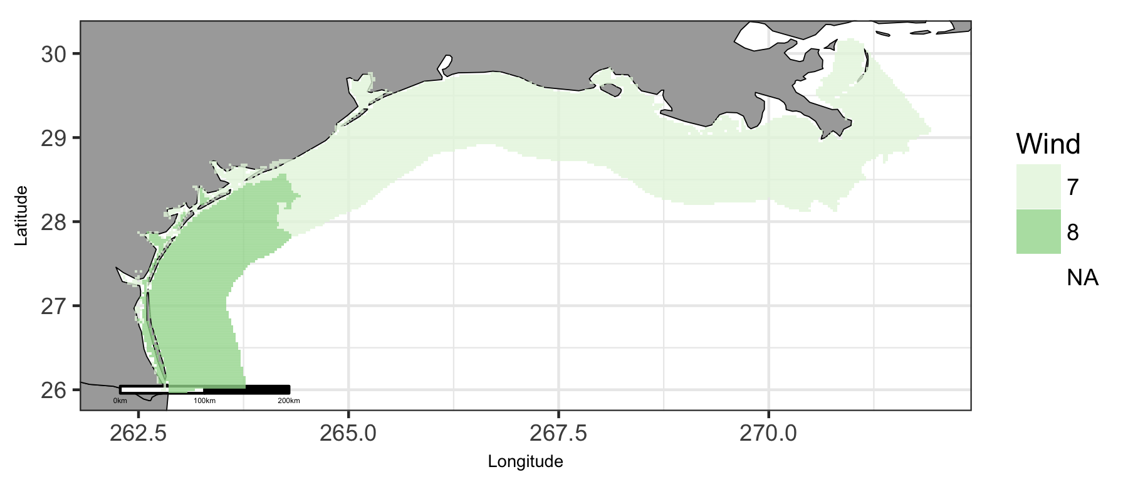

Map of viable wind in Gulf of Mexico region.

### Gulf of Mexico: Plot of Uses by Wind

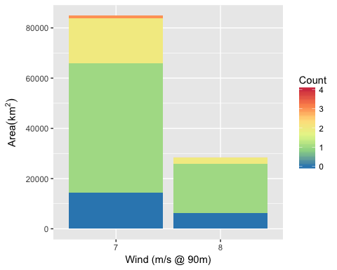

Area of Cumulative Ocean Use by Wind (m/s @ 90m) for Gulf of Mexico region. Cumulative use are counted and summarized by Wind (m/s @ 90m) and area.

### Gulf of Mexico: Table of Uses by Wind

Table 14: Area (km2) of ocean use layers by wind (m/s) bin for Gulf of Mexico region. Layers are grouped by dataset. The total area considered was limited to maximum depth of 1000 m and minimum wind of Inf m/s. The layer’s bar graph shows percent total coverage for considered area.

|  |  |  |  |  |  |
| --- | --- | --- | --- | --- | --- |
| **Dataset**, Layer |  | % | 7 | 8 | Total |
| **Total Area** |  | 100 | 84,823 | 28,521 | 113,343 |
| **Active Oil & Gas Leases** |  |  |  |  |  |
| Active Oil & Gas Leases |  | 13 | 14,401 | 242 | 14,643 |
| **Essential Fish Habitat** |  |  |  |  |  |
| EFH |  | 11 | 9,670 | 2,763 | 12,433 |
| **Marine Protected Areas** |  |  |  |  |  |
| Bureau of Ocean Energy Management |  | 1 | 618 |  | 618 |
| National Estuarine Research Reserve System |  | 0 | 358 | 62 | 420 |
| National Marine Fisheries Service |  | 68 | 58,833 | 18,244 | 77,077 |
| National Park Service |  | 0 | 78 | 162 | 239 |
| National Wildlife Refuge System |  | 1 | 109 | 539 | 648 |
| State MPA |  | 0 | 519 |  | 519 |
| **Shipping Lanes** |  |  |  |  |  |
| Shipping Lanes |  | 8 | 5,490 | 3,037 | 8,527 |

## Hawaii

### Hawaii: Map of Uses

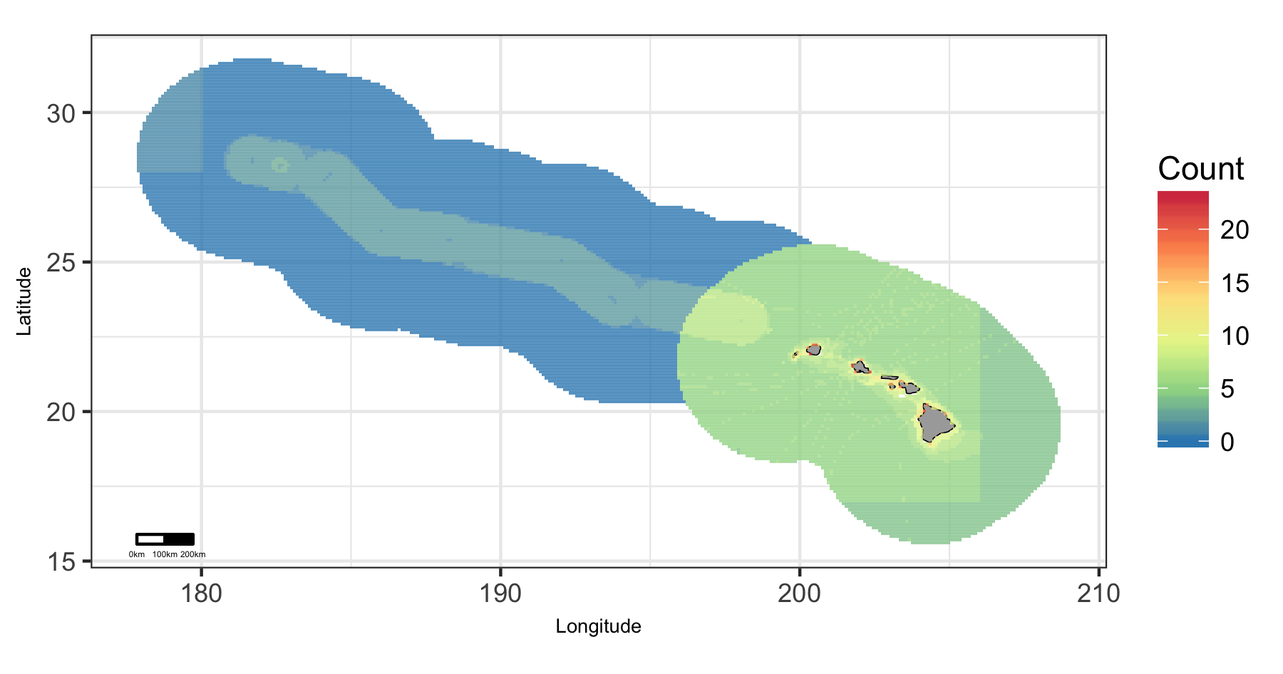

Map of cumulative ocean use in Hawaii region.

### Hawaii: Map of Depth

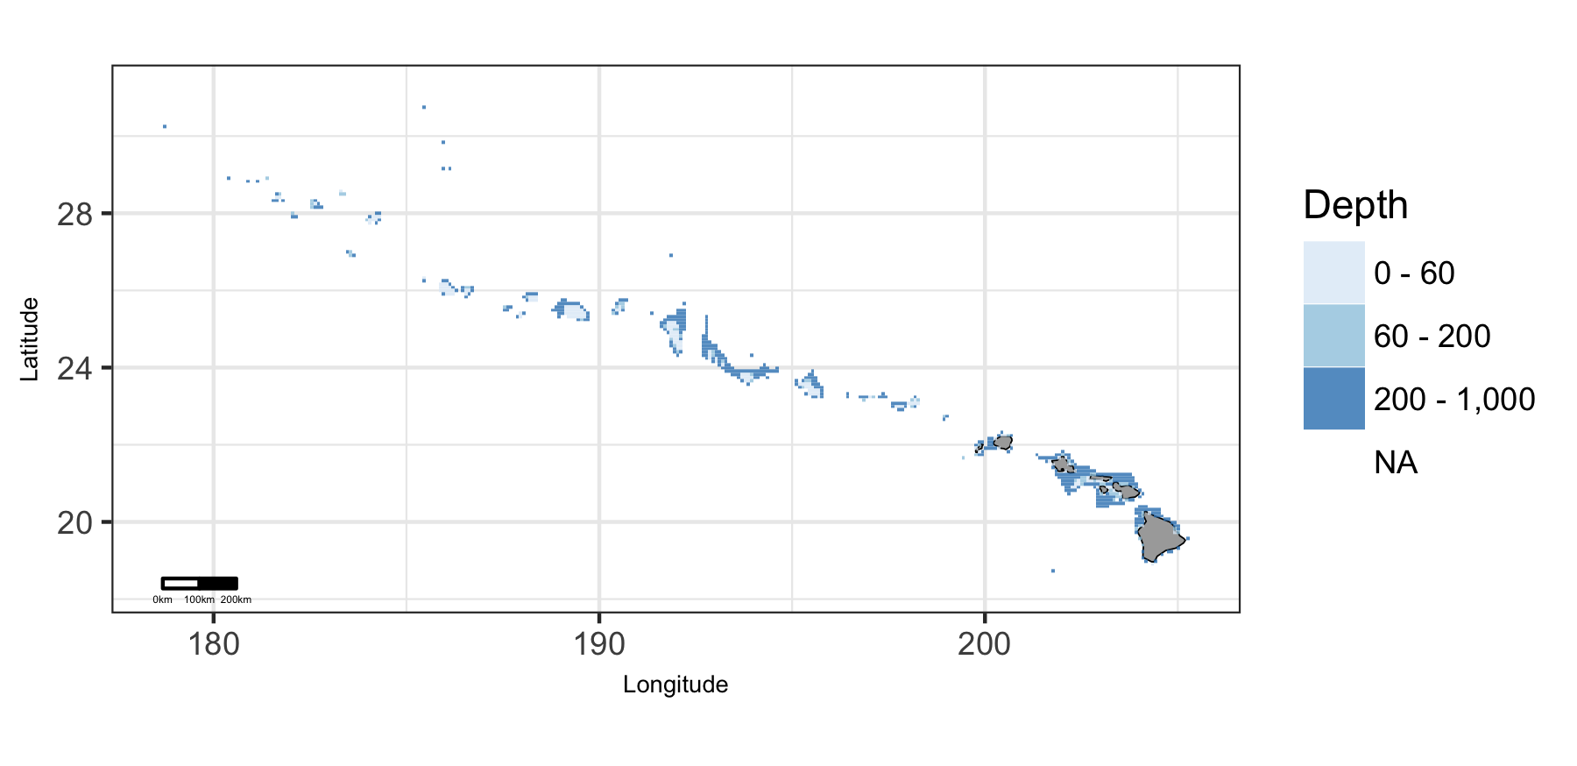

Map of viable depth in Hawaii region.

### Hawaii: Plot of Uses by Depth

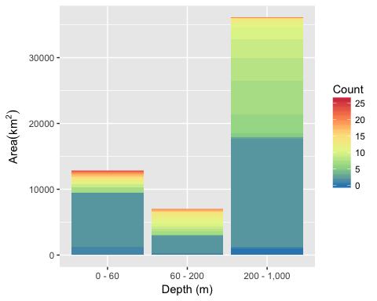

Area of Cumulative Ocean Use by Depth (m) for Hawaii region. Cumulative use are counted and summarized by Depth (m) and area.

### Hawaii: Table of Uses by Depth

Table 15: Area (km2) of ocean use layers by depth (m) bin for Hawaii region. Layers are grouped by dataset. The total area considered was limited to maximum depth of 1000 m. The layer’s bar graph shows percent total coverage for considered area.

|  |  |  |  |  |  |  |
| --- | --- | --- | --- | --- | --- | --- |
| **Dataset**, Layer |  | % | 0 - 60 | 60 - 200 | 200 - 1,000 | Total |
| **Total Area** |  | 100 | 12,800 | 6,968 | 36,084 | 55,852 |
| **Marine Protected Areas** |  |  |  |  |  |  |
| Marine National Monuments |  | 57 | 10,120 | 3,300 | 18,622 | 32,042 |
| National Marine Fisheries Service |  | 54 | 8,711 | 3,094 | 18,443 | 30,248 |
| National Marine Sanctuaries |  | 6 | 1,394 | 1,763 | 220 | 3,378 |
| National Park Service |  | 0 | 4 |  |  | 4 |
| National Wildlife Refuge System |  | 1 | 165 | 173 | 200 | 538 |
| State MPA |  | 4 | 208 | 622 | 1,407 | 2,238 |
| **Ocean Use Atlas for Hawaii** |  |  |  |  |  |  |
| Aquaculture |  | 1 | 227 | 286 | 306 | 819 |
| Com Dive Fishing |  | 4 | 1,197 | 713 | 149 | 2,060 |
| Com Fishing Fixed |  | 4 | 939 | 420 | 1,085 | 2,444 |
| Com Fishing Mobile |  | 10 | 1,172 | 1,277 | 3,245 | 5,694 |
| Com Gathering Shore |  | 0 | 127 | 34 | 33 | 194 |
| Com Pelagic Fishing |  | 45 | 3,294 | 3,901 | 18,208 | 25,404 |
| Cruise Ships |  | 28 | 1,885 | 2,675 | 10,841 | 15,401 |
| Fishing Shore |  | 1 | 321 | 53 | 53 | 427 |
| Kayak Fishing |  | 10 | 935 | 1,038 | 3,878 | 5,851 |
| Military Operations |  | 45 | 3,294 | 3,901 | 18,208 | 25,404 |
| Mining Mineral Ext |  | 0 | 53 | 3 | 2 | 59 |
| Motorized Boating |  | 45 | 3,294 | 3,901 | 18,208 | 25,404 |
| Ocean Dumping |  | 1 | 244 | 82 | 427 | 753 |
| Offshore Alt Energy |  | 1 | 92 | 136 | 161 | 389 |
| Paddling |  | 33 | 2,134 | 3,348 | 13,161 | 18,643 |
| Perm Research Areas |  | 9 | 1,639 | 1,976 | 1,251 | 4,866 |
| Rec Dive Fishing |  | 4 | 1,431 | 740 | 160 | 2,331 |
| Rec Fishing Fixed |  | 3 | 869 | 605 | 379 | 1,852 |
| Rec Fishing Mobile |  | 22 | 2,452 | 3,206 | 6,375 | 12,033 |
| Rec Fishing Pel Boats |  | 45 | 3,294 | 3,901 | 18,208 | 25,404 |
| Rec Gathering Shore |  | 1 | 266 | 36 | 33 | 336 |
| Scuba Snorkeling |  | 4 | 1,622 | 556 | 137 | 2,315 |
| Shipping |  | 45 | 3,294 | 3,901 | 18,208 | 25,404 |
| Shore Use |  | 1 | 339 | 35 | 19 | 394 |
| Surface Board Sports |  | 4 | 1,290 | 644 | 437 | 2,371 |
| Swimming |  | 5 | 884 | 642 | 1,138 | 2,664 |
| Underwater Cables |  | 5 | 288 | 465 | 1,953 | 2,705 |
| Underwater Pipelines |  | 0 | 96 | 11 | 14 | 121 |
| Wildlife Viewing Sea |  | 14 | 1,412 | 1,912 | 4,446 | 7,770 |

### Hawaii: Map of Wave

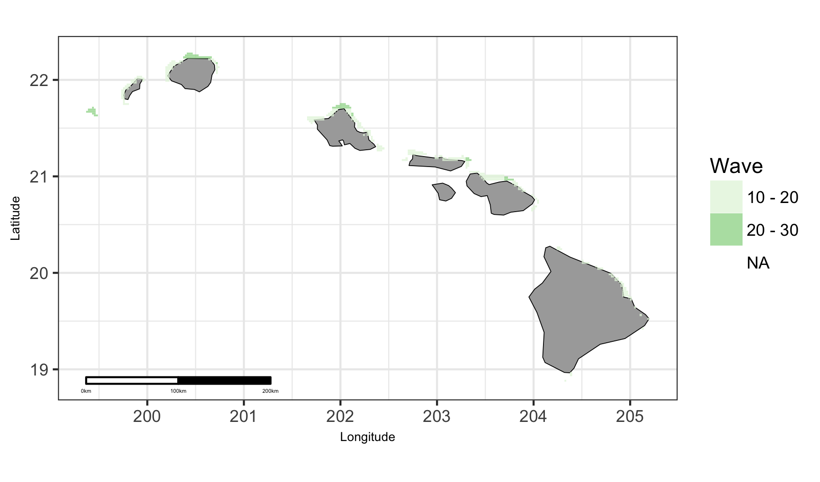

Map of viable wave in Hawaii region.

### Hawaii: Plot of Uses by Wave

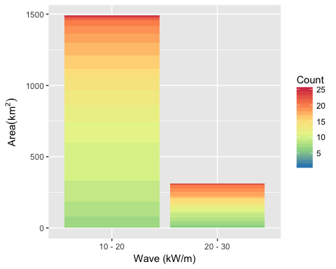

Area of Cumulative Ocean Use by Wave (kW/m) for Hawaii region. Cumulative use are counted and summarized by Wave (kW/m) and area.

### Hawaii: Table of Uses by Wave

Table 16: Area (km2) of ocean use layers by wave (kW/m) bin for Hawaii region. Layers are grouped by dataset. The total area considered was limited to maximum depth of 200 m and minimum wave of Inf kW/m. The layer’s bar graph shows percent total coverage for considered area.

|  |  |  |  |  |  |
| --- | --- | --- | --- | --- | --- |
| **Dataset**, Layer |  | % | 10 - 20 | 20 - 30 | Total |
| **Total Area** |  | 100 | 1,489 | 311 | 1,800 |
| **Marine Protected Areas** |  |  |  |  |  |
| National Marine Sanctuaries |  | 20 | 189 | 175 | 363 |
| National Park Service |  | 0 | 3 |  | 3 |
| State MPA |  | 12 | 186 | 26 | 212 |
| **Ocean Use Atlas for Hawaii** |  |  |  |  |  |
| Aquaculture |  | 5 | 85 |  | 85 |
| Com Dive Fishing |  | 46 | 701 | 135 | 835 |
| Com Fishing Fixed |  | 34 | 487 | 121 | 608 |
| Com Fishing Mobile |  | 61 | 850 | 251 | 1,101 |
| Com Gathering Shore |  | 2 | 35 | 2 | 37 |
| Com Pelagic Fishing |  | 100 | 1,488 | 311 | 1,799 |
| Cruise Ships |  | 52 | 811 | 128 | 939 |
| Fishing Shore |  | 5 | 82 | 8 | 90 |
| Kayak Fishing |  | 45 | 654 | 152 | 806 |
| Military Operations |  | 100 | 1,488 | 311 | 1,799 |
| Mining Mineral Ext |  | 0 | 6 | 2 | 9 |
| Motorized Boating |  | 100 | 1,488 | 311 | 1,799 |
| Ocean Dumping |  | 7 | 124 | 10 | 134 |
| Offshore Alt Energy |  | 10 | 103 | 81 | 184 |
| Paddling |  | 97 | 1,488 | 252 | 1,741 |
| Perm Research Areas |  | 27 | 304 | 189 | 493 |
| Rec Dive Fishing |  | 49 | 733 | 142 | 875 |
| Rec Fishing Fixed |  | 42 | 607 | 141 | 748 |
| Rec Fishing Mobile |  | 91 | 1,347 | 290 | 1,636 |
| Rec Fishing Pel Boats |  | 100 | 1,488 | 311 | 1,799 |
| Rec Gathering Shore |  | 4 | 58 | 6 | 63 |
| Scuba Snorkeling |  | 36 | 563 | 90 | 654 |
| Shipping |  | 100 | 1,488 | 311 | 1,799 |
| Shore Use |  | 4 | 69 | 6 | 75 |
| Surface Board Sports |  | 34 | 525 | 92 | 617 |
| Swimming |  | 20 | 330 | 35 | 365 |
| Underwater Cables |  | 2 | 35 |  | 35 |
| Underwater Pipelines |  | 0 | 3 |  | 3 |
| Wildlife Viewing Sea |  | 56 | 804 | 195 | 999 |

### Hawaii: Map of Wind

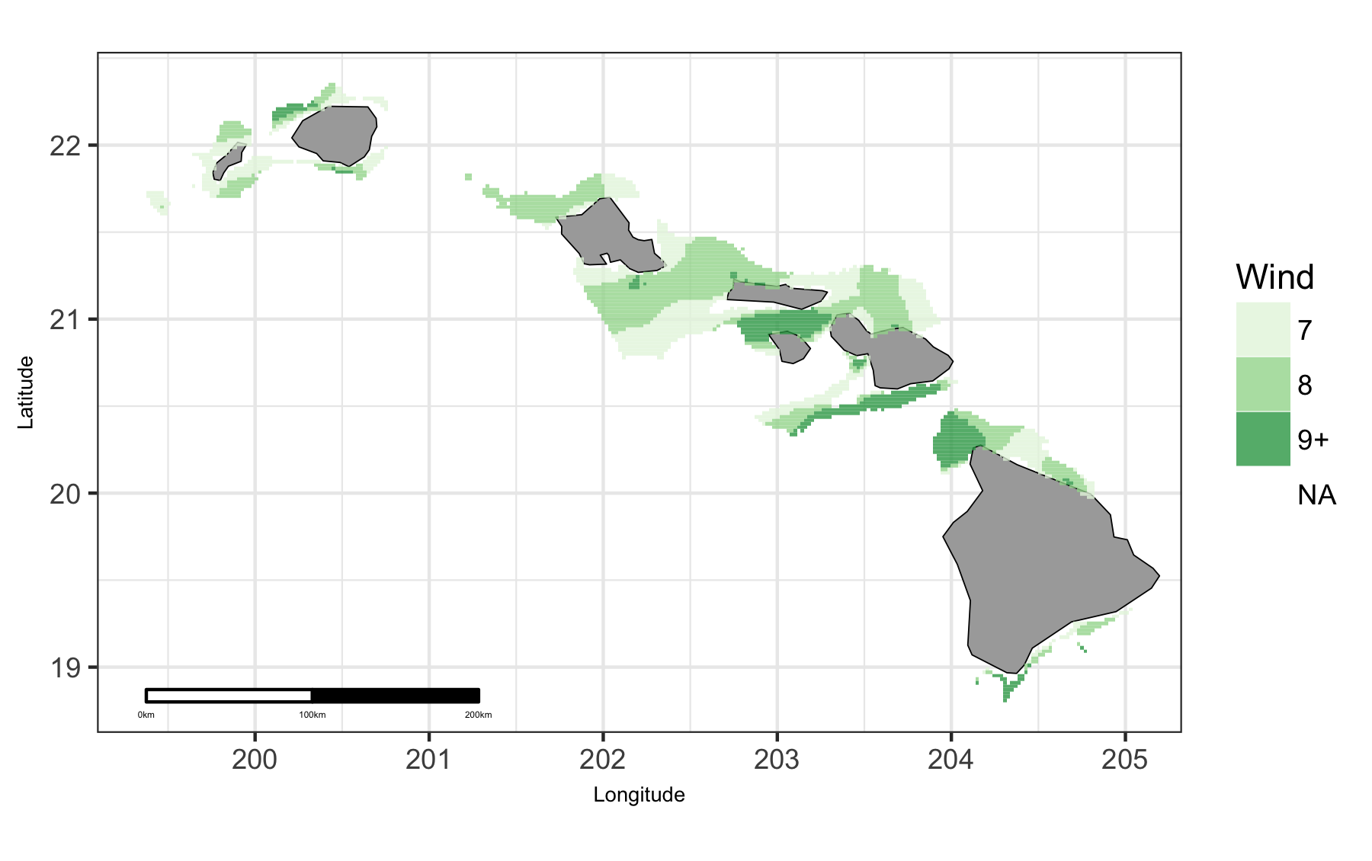

Map of viable wind in Hawaii region.

### Hawaii: Plot of Uses by Wind

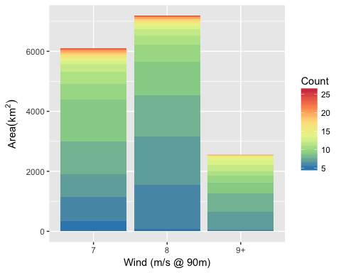

Area of Cumulative Ocean Use by Wind (m/s @ 90m) for Hawaii region. Cumulative use are counted and summarized by Wind (m/s @ 90m) and area.

### Hawaii: Table of Uses by Wind

Table 17: Area (km2) of ocean use layers by wind (m/s) bin for Hawaii region. Layers are grouped by dataset. The total area considered was limited to maximum depth of 1000 m and minimum wind of Inf m/s. The layer’s bar graph shows percent total coverage for considered area.

|  |  |  |  |  |  |  |
| --- | --- | --- | --- | --- | --- | --- |
| **Dataset**, Layer |  | % | 7 | 8 | 9+ | Total |
| **Total Area** |  | 100 | 6,095 | 7,178 | 2,546 | 15,818 |
| **Marine Protected Areas** |  |  |  |  |  |  |
| National Marine Sanctuaries |  | 14 | 1,084 | 548 | 566 | 2,199 |
| National Park Service |  | 0 | 1 | 1 |  | 2 |
| State MPA |  | 11 | 1,024 | 482 | 186 | 1,691 |
| **Ocean Use Atlas for Hawaii** |  |  |  |  |  |  |
| Aquaculture |  | 4 | 268 | 62 | 317 | 647 |
| Com Dive Fishing |  | 6 | 549 | 301 | 87 | 936 |
| Com Fishing Fixed |  | 9 | 804 | 666 | 10 | 1,479 |
| Com Fishing Mobile |  | 18 | 1,387 | 1,104 | 289 | 2,780 |
| Com Gathering Shore |  | 0 | 27 | 23 | 12 | 63 |
| Com Pelagic Fishing |  | 100 | 6,095 | 7,178 | 2,546 | 15,818 |
| Cruise Ships |  | 63 | 3,513 | 4,006 | 2,510 | 10,029 |
| Fishing Shore |  | 1 | 73 | 56 | 35 | 164 |
| Kayak Fishing |  | 19 | 1,149 | 1,131 | 728 | 3,008 |
| Military Operations |  | 100 | 6,095 | 7,178 | 2,546 | 15,818 |
| Mining Mineral Ext |  | 0 | 24 | 6 |  | 30 |
| Motorized Boating |  | 100 | 6,095 | 7,178 | 2,546 | 15,818 |
| Ocean Dumping |  | 3 | 203 | 313 | 3 | 519 |
| Offshore Alt Energy |  | 2 | 204 | 124 |  | 328 |
| Paddling |  | 81 | 4,441 | 5,835 | 2,489 | 12,765 |
| Perm Research Areas |  | 18 | 1,379 | 811 | 617 | 2,807 |
| Rec Dive Fishing |  | 7 | 597 | 357 | 140 | 1,094 |
| Rec Fishing Fixed |  | 7 | 462 | 592 | 18 | 1,073 |
| Rec Fishing Mobile |  | 48 | 3,257 | 3,028 | 1,274 | 7,559 |
| Rec Fishing Pel Boats |  | 100 | 6,095 | 7,178 | 2,546 | 15,818 |
| Rec Gathering Shore |  | 1 | 54 | 45 | 29 | 127 |
| Scuba Snorkeling |  | 7 | 493 | 314 | 240 | 1,048 |
| Shipping |  | 100 | 6,095 | 7,178 | 2,546 | 15,818 |
| Shore Use |  | 1 | 61 | 65 | 39 | 165 |
| Surface Board Sports |  | 8 | 450 | 530 | 302 | 1,282 |
| Swimming |  | 9 | 324 | 1,044 | 77 | 1,445 |
| Underwater Cables |  | 11 | 296 | 1,058 | 381 | 1,734 |
| Underwater Pipelines |  | 0 | 57 | 6 | 5 | 69 |
| Wildlife Viewing Sea |  | 29 | 1,942 | 1,873 | 703 | 4,518 |

## Pacific Islands

### Pacific Islands: Map of Uses

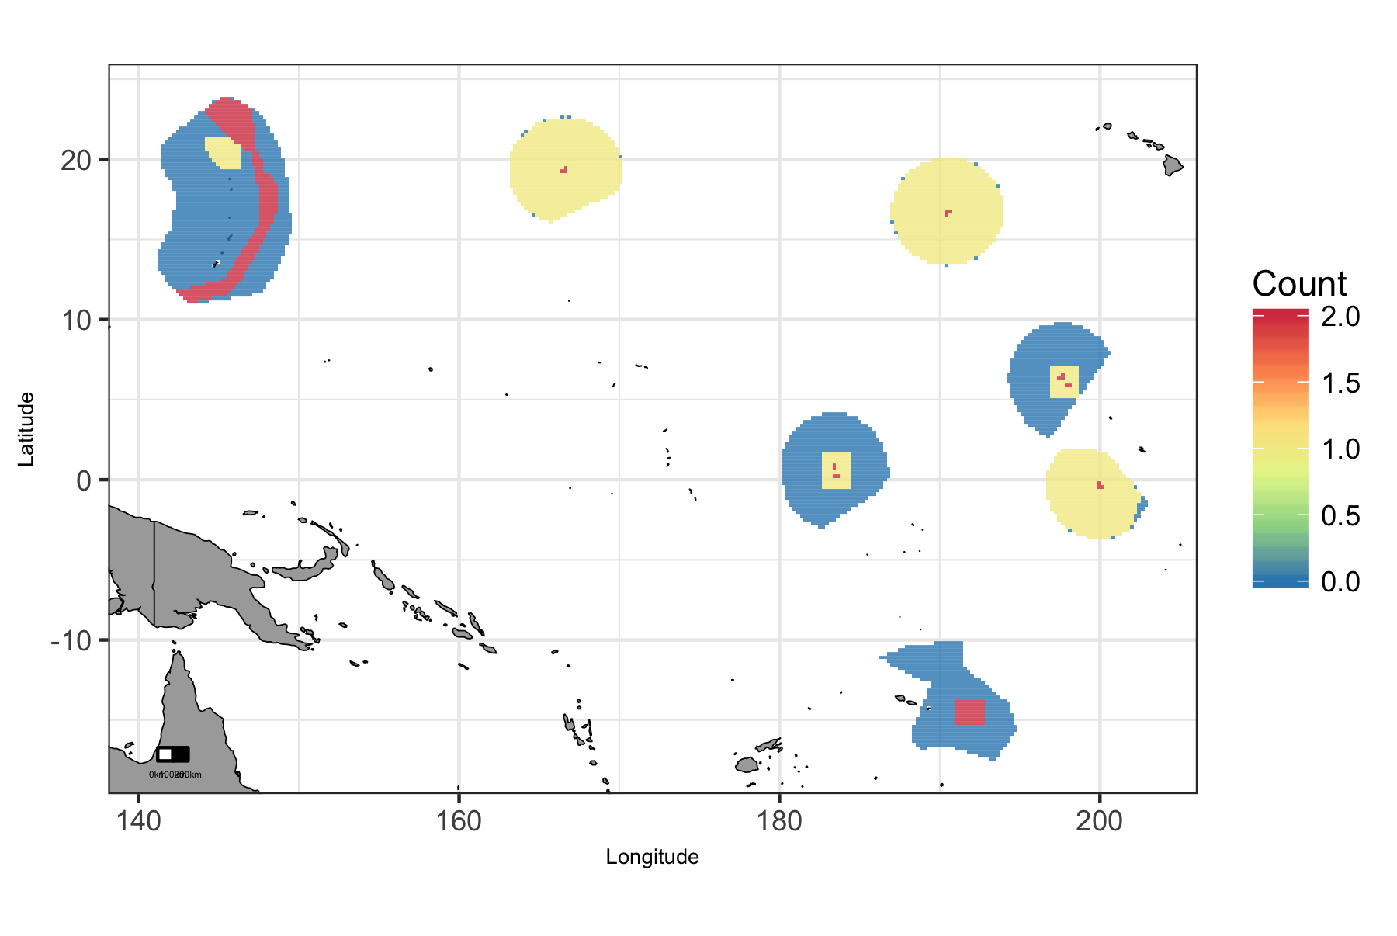

Map of cumulative ocean use in Pacific Islands region.

### Pacific Islands: Map of Depth

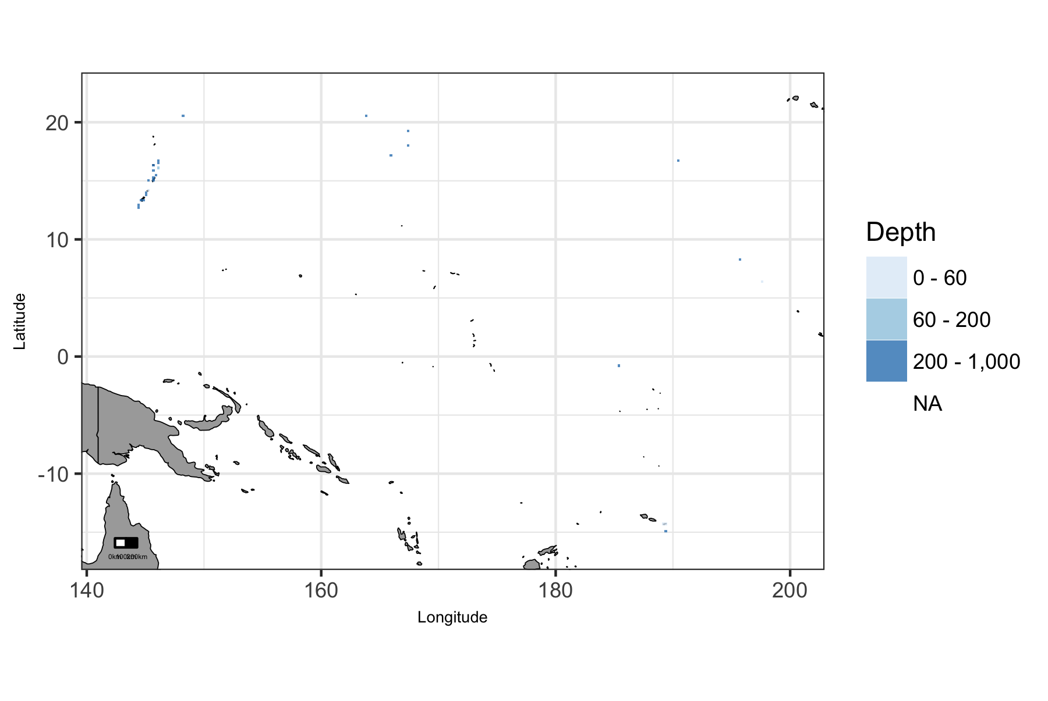

Map of viable depth in Pacific Islands region.

### Pacific Islands: Plot of Uses by Depth

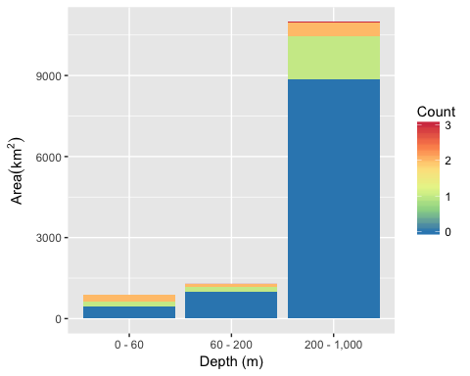

Area of Cumulative Ocean Use by Depth (m) for Pacific Islands region. Cumulative use are counted and summarized by Depth (m) and area.

### Pacific Islands: Table of Uses by Depth

Table 18: Area (km2) of ocean use layers by depth (m) bin for Pacific Islands region. Layers are grouped by dataset. The total area considered was limited to maximum depth of 1000 m. The layer’s bar graph shows percent total coverage for considered area.

|  |  |  |  |  |  |  |
| --- | --- | --- | --- | --- | --- | --- |
| **Dataset**, Layer |  | % | 0 - 60 | 60 - 200 | 200 - 1,000 | Total |
| **Total Area** |  | 100 | 888 | 1,294 | 10,982 | 13,164 |
| **Marine Protected Areas** |  |  |  |  |  |  |
| American Samoa |  | 0 | 1 | 1 |  | 2 |
| Guam |  | 0 | 9 | 12 | 3 | 25 |
| Mariana Islands |  | 0 | 7 | 1 |  | 7 |
| Marine National Monuments |  | 21 | 426 | 271 | 2,077 | 2,775 |
| National Marine Sanctuaries |  | 1 | 6 | 24 | 63 | 93 |
| National Park Service |  | 0 | 3 | 1 |  | 4 |
| National Wildlife Refuge System |  | 7 | 258 | 111 | 529 | 898 |

## West

### West: Map of Uses

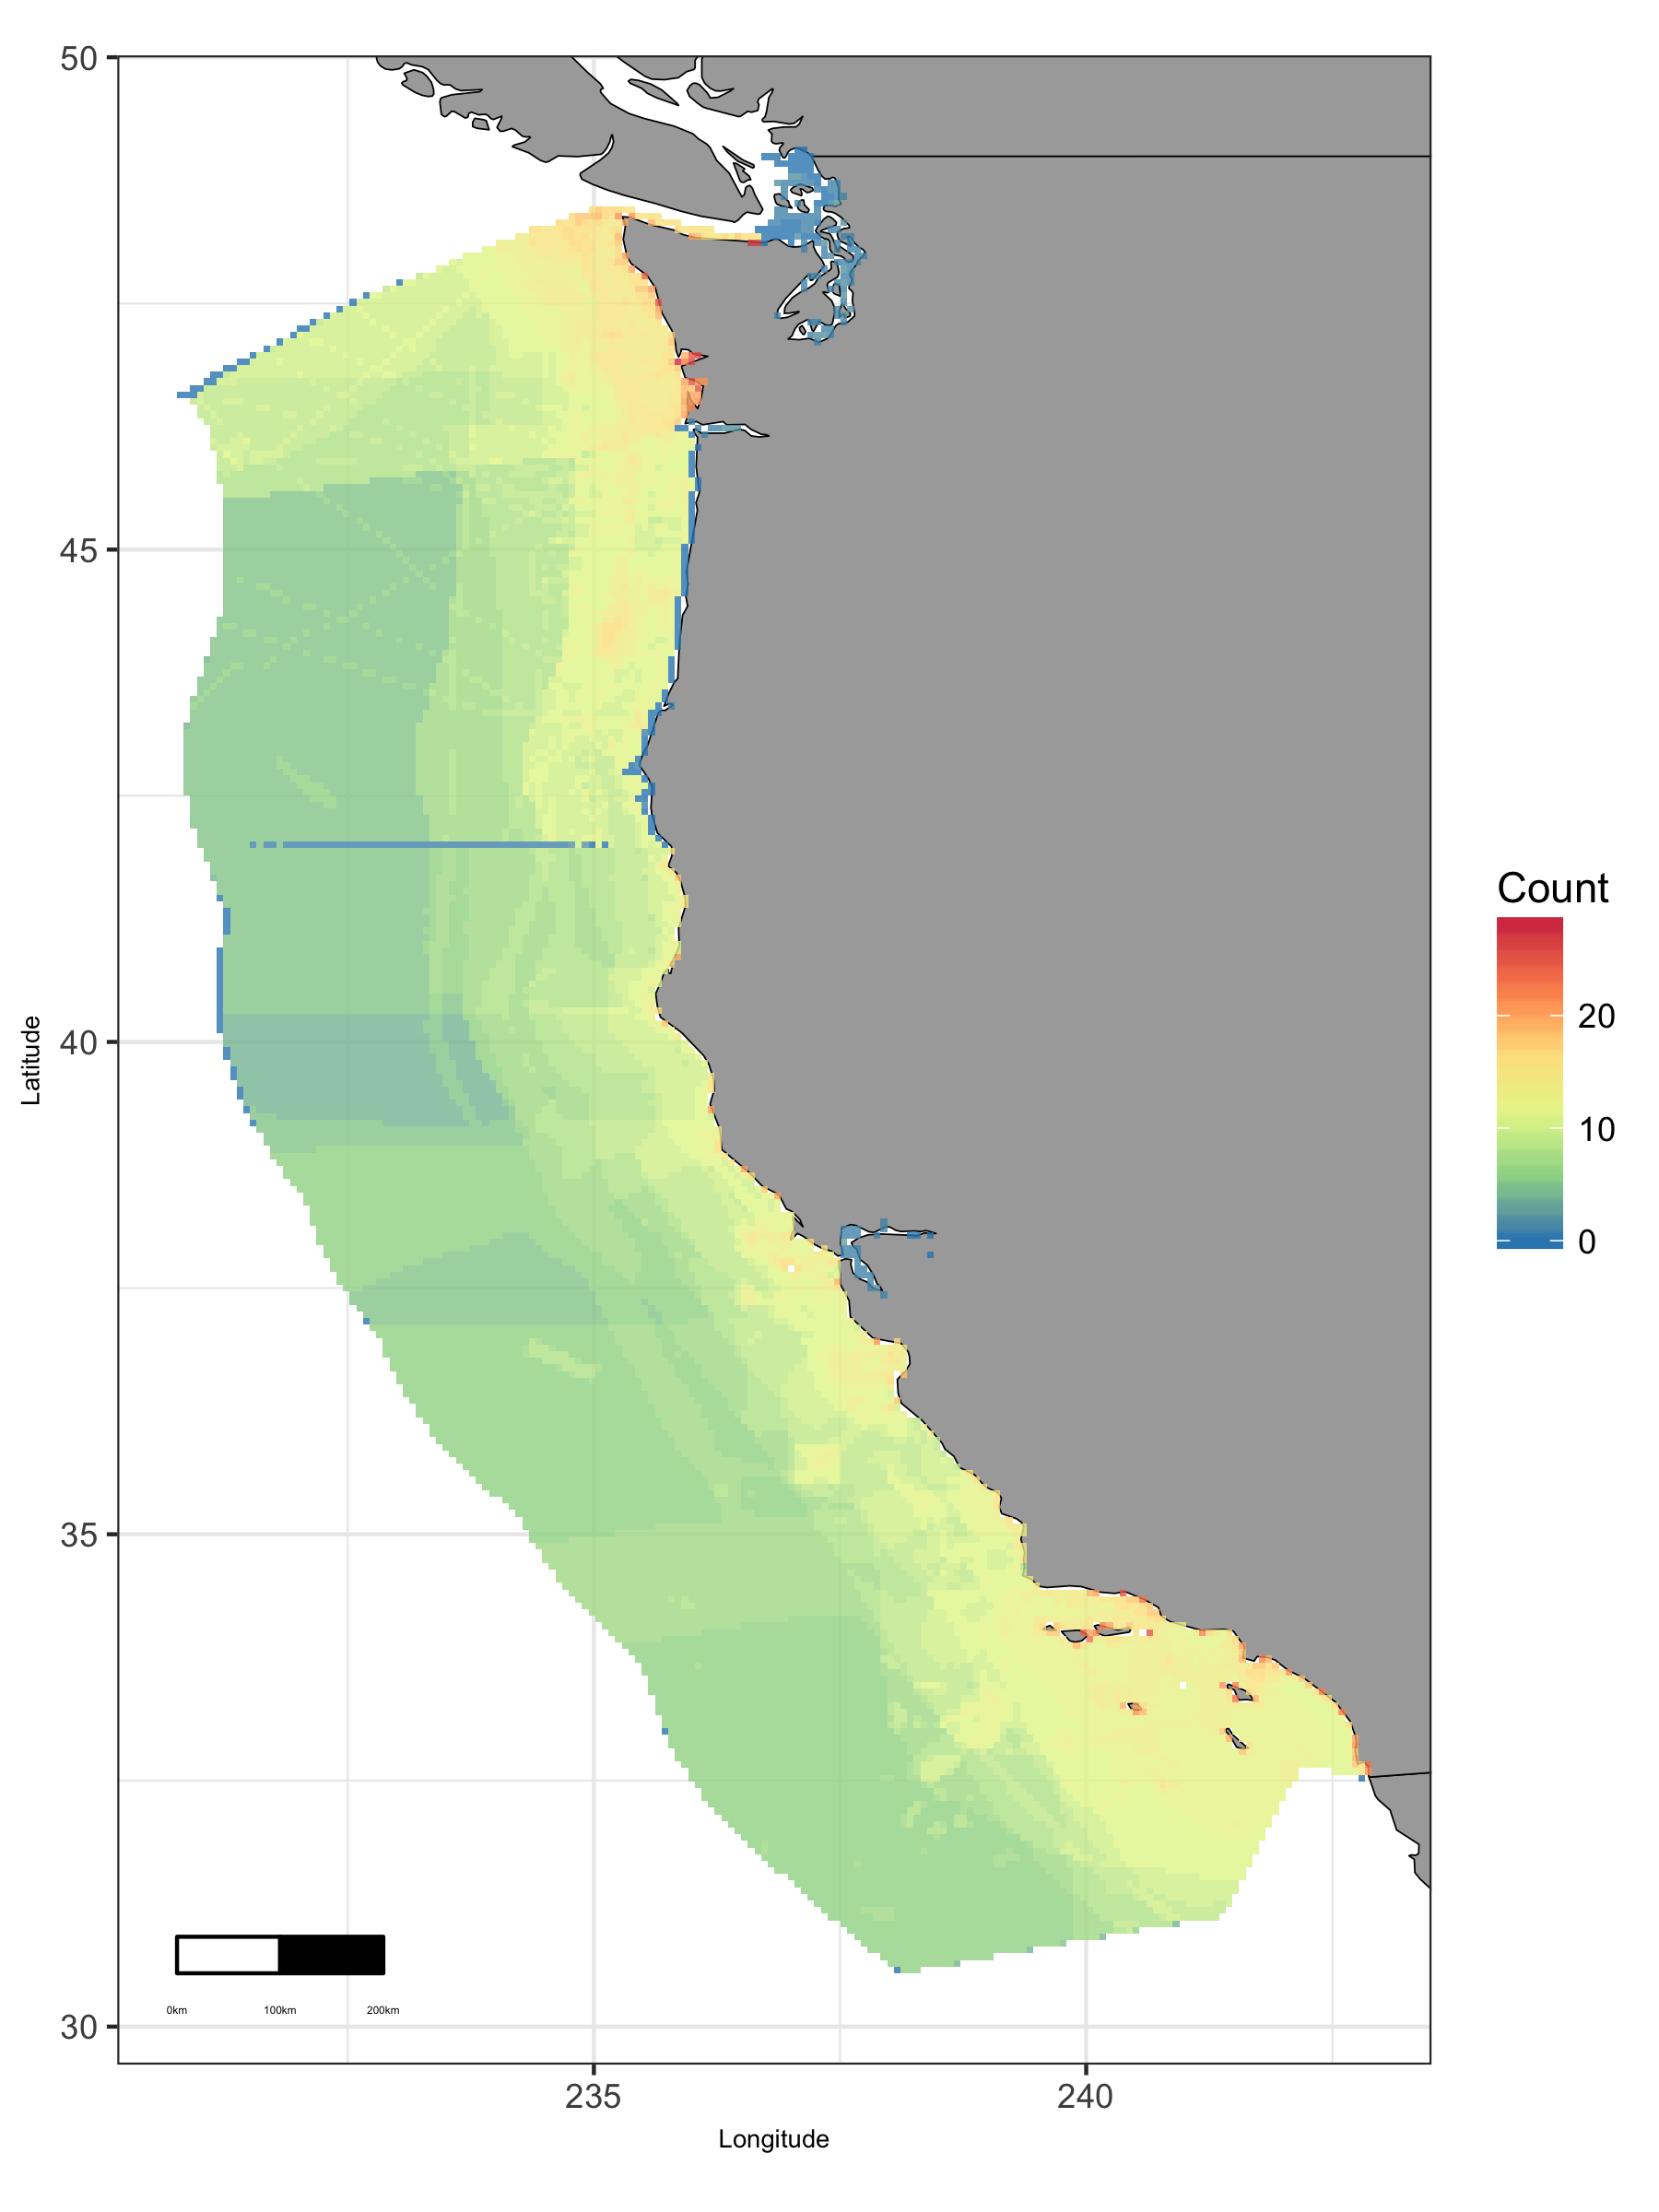

Map of cumulative ocean use in West region.

### West: Map of Depth

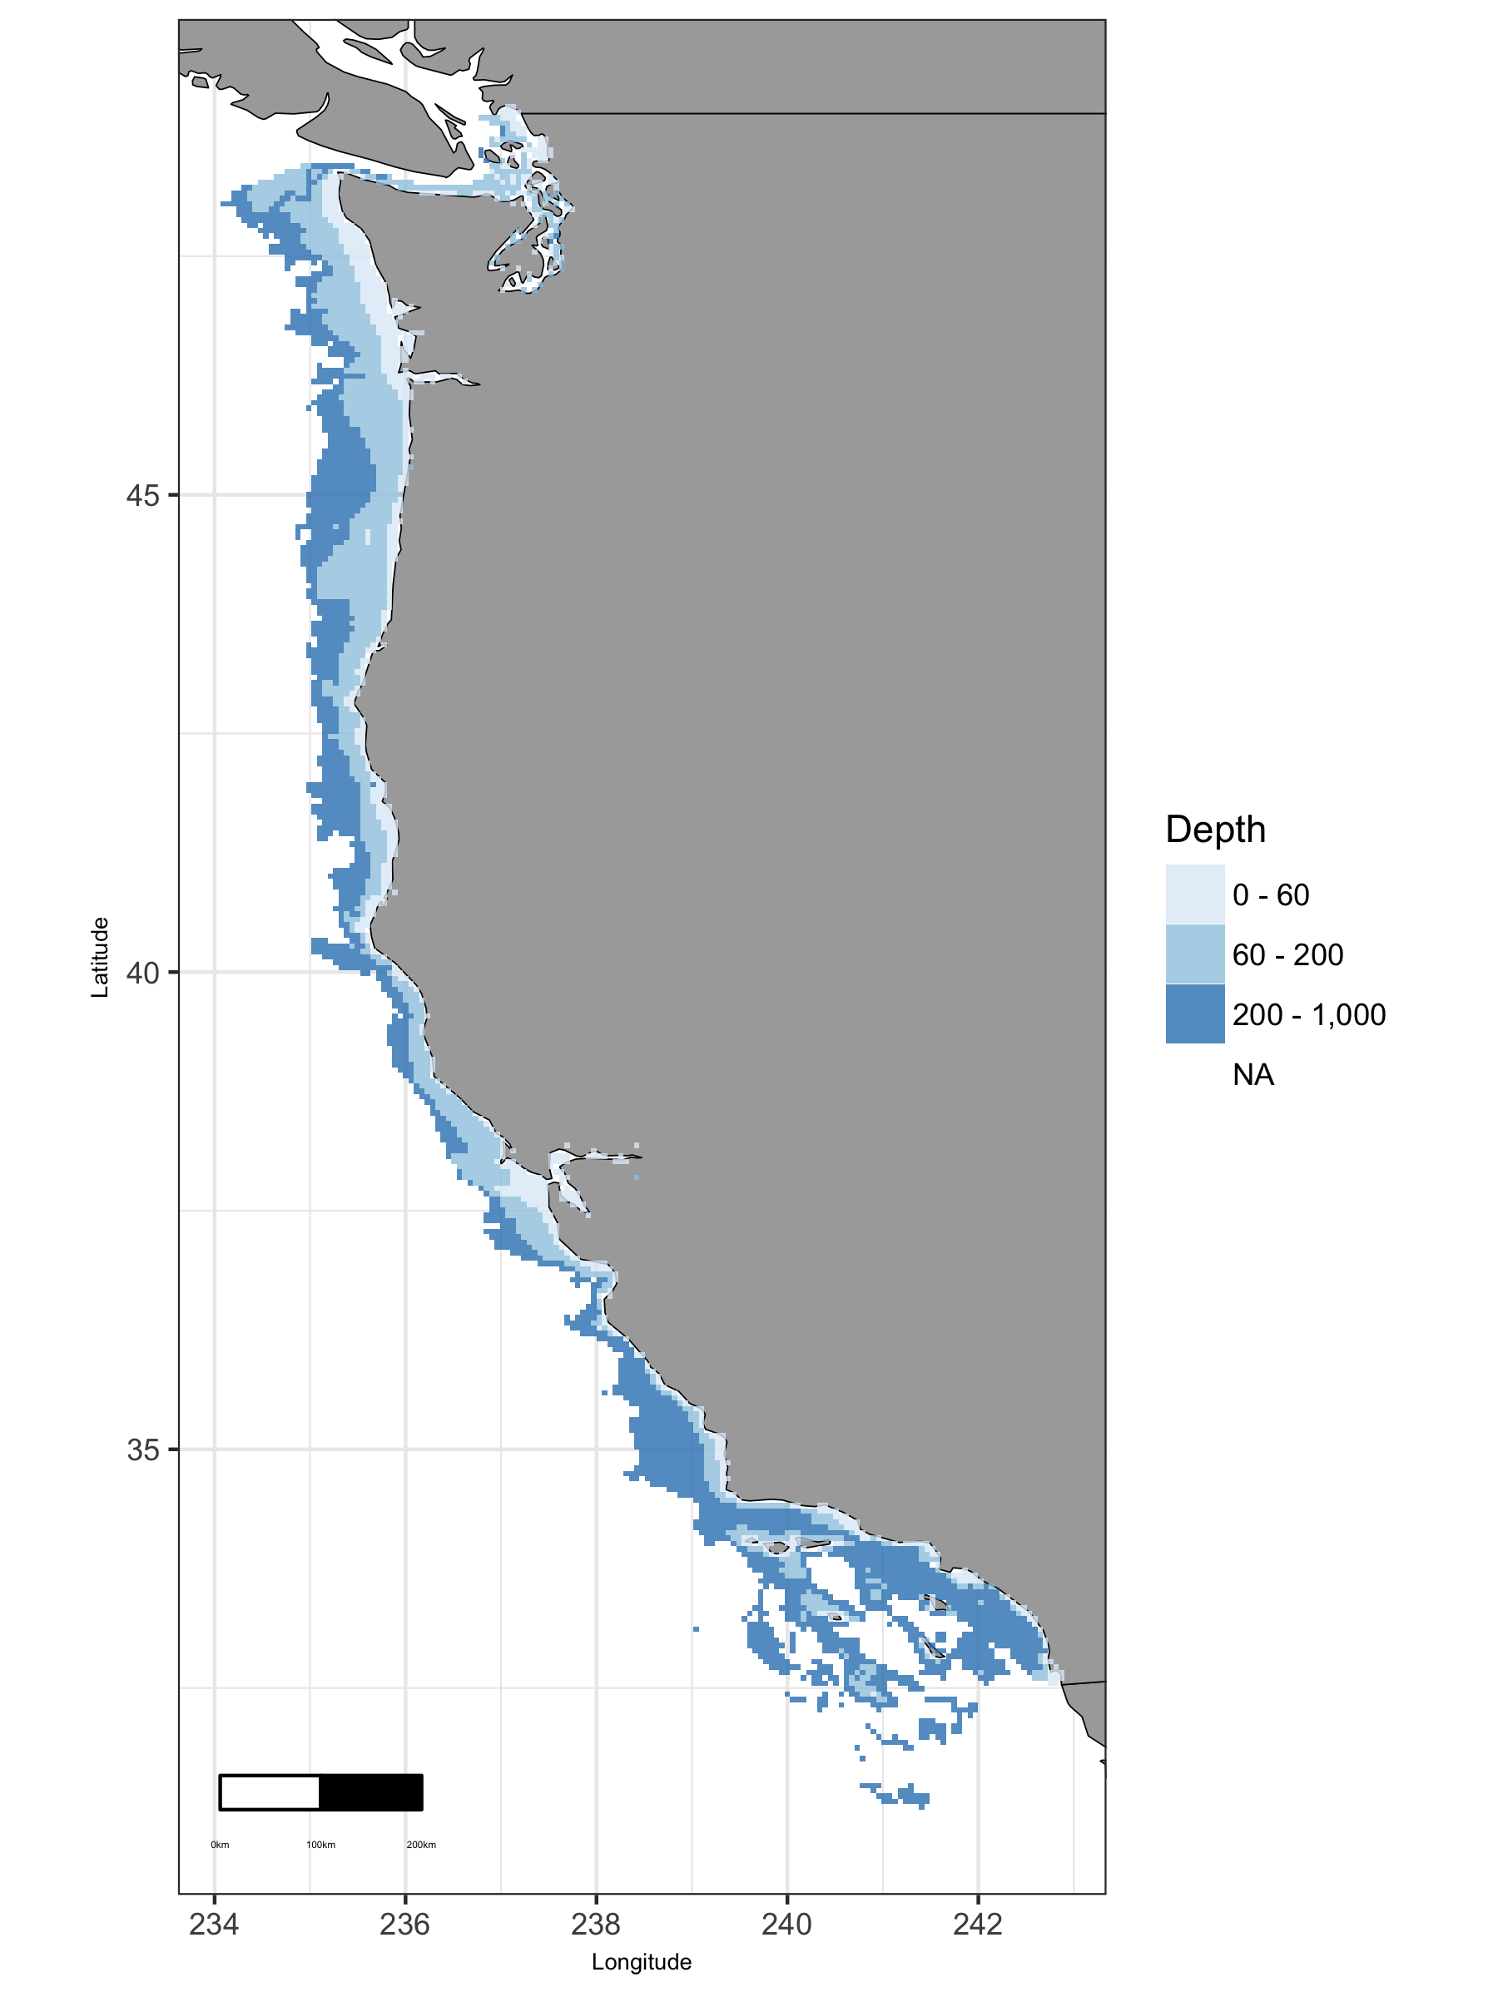

Map of viable depth in West region.

### West: Plot of Uses by Depth

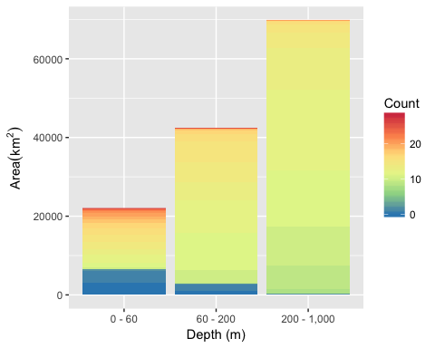

Area of Cumulative Ocean Use by Depth (m) for West region. Cumulative use are counted and summarized by Depth (m) and area.

### West: Table of Uses by Depth

Table 19: Area (km2) of ocean use layers by depth (m) bin for West region. Layers are grouped by dataset. The total area considered was limited to maximum depth of 1000 m. The layer’s bar graph shows percent total coverage for considered area.

|  |  |  |  |  |  |  |
| --- | --- | --- | --- | --- | --- | --- |
| **Dataset**, Layer |  | % | 0 - 60 | 60 - 200 | 200 - 1,000 | Total |
| **Total Area** |  | 100 | 22,032 | 42,357 | 69,766 | 134,156 |
| **Active Oil & Gas Leases** |  |  |  |  |  |  |
| Active Oil & Gas Leases |  | 1 | 118 | 355 | 394 | 867 |
| **Aquaculture** |  |  |  |  |  |  |
| Shellfish |  | 0 | 3 |  |  | 3 |
| **Essential Fish Habitat** |  |  |  |  |  |  |
| Canopy Kelp |  | 1 | 818 | 27 | 1 | 847 |
| Estuaries |  | 3 | 3,307 | 968 | 77 | 4,352 |
| Groundfish |  | 4 | 2,256 | 1,052 | 2,322 | 5,630 |
| Rocky Reefs |  | 7 | 951 | 3,540 | 4,813 | 9,304 |
| Seagrass |  | 0 | 504 | 1 |  | 505 |
| **Marine Protected Areas** |  |  |  |  |  |  |
| Bureau of Ocean Energy Management |  | 0 | 26 | 100 | 100 | 227 |
| National Estuarine Research Reserve System |  | 0 | 45 |  |  | 45 |
| National Marine Fisheries Service |  | 16 | 919 | 5,157 | 15,047 | 21,123 |
| National Marine Sanctuaries |  | 18 | 5,758 | 11,132 | 7,556 | 24,446 |
| National Park Service |  | 0 | 357 | 81 | 2 | 440 |
| National Wildlife Refuge System |  | 0 | 195 | 9 | 2 | 206 |
| State MPA |  | 4 | 2,512 | 2,205 | 355 | 5,071 |
| **Ocean Use Atlas for California** |  |  |  |  |  |  |
| Alt Energy Future |  | 14 | 3,104 | 10,931 | 5,263 | 19,299 |
| Aquaculture |  | 1 | 1,129 | 702 | 142 | 1,972 |
| Beach |  | 1 | 1,604 | 91 | 2 | 1,697 |
| Cables |  | 12 | 2,324 | 2,948 | 11,192 | 16,464 |
| Com Benthic Fixed |  | 55 | 9,511 | 17,632 | 47,267 | 74,410 |
| Com Benthic Mobile |  | 38 | 4,675 | 11,801 | 33,910 | 50,386 |
| Com Dive |  | 3 | 2,804 | 602 | 74 | 3,481 |
| Com Kelp |  | 1 | 1,144 | 127 | 1 | 1,272 |
| Com Pelagic |  | 58 | 9,380 | 17,566 | 50,981 | 77,927 |
| Hunting |  | 29 | 3,368 | 5,594 | 30,019 | 38,981 |
| Kayak Fishing |  | 10 | 7,084 | 4,865 | 904 | 12,853 |
| Military |  | 59 | 9,876 | 18,121 | 51,257 | 79,254 |
| Mining |  | 0 | 111 |  |  | 111 |
| Motorized Boating |  | 58 | 9,889 | 18,121 | 50,359 | 78,369 |
| Oil |  | 54 | 5,634 | 16,510 | 50,418 | 72,563 |
| Paddling |  | 12 | 7,889 | 5,398 | 3,326 | 16,613 |
| Rec Boat |  | 58 | 9,594 | 17,797 | 50,944 | 78,336 |
| Rec Dive |  | 7 | 8,249 | 1,323 | 473 | 10,045 |
| Rec Shore Harvest |  | 30 | 3,995 | 5,608 | 30,019 | 39,621 |
| Sailing |  | 59 | 9,889 | 18,121 | 51,225 | 79,236 |
| Scuba |  | 5 | 5,010 | 1,278 | 138 | 6,427 |
| Shipping |  | 47 | 4,169 | 12,263 | 46,146 | 62,578 |
| Shore Fishing |  | 1 | 1,679 | 113 | 3 | 1,795 |
| Surface Sports |  | 5 | 4,556 | 1,435 | 823 | 6,814 |
| Swimming |  | 2 | 1,245 | 286 | 663 | 2,193 |
| Tidepooling |  | 1 | 1,255 | 97 | 2 | 1,354 |
| Wildlife Viewing |  | 52 | 9,508 | 17,485 | 42,551 | 69,543 |
| **Ocean Use Atlas for Oregon & Washington** |  |  |  |  |  |  |
| Aquaculture |  | 0 | 496 |  |  | 496 |
| Com Dive Fishing |  | 0 | 152 | 9 |  | 161 |
| Com Fishing Fixed |  | 34 | 5,646 | 21,350 | 18,306 | 45,302 |
| Com Fishing Mobile |  | 34 | 5,646 | 21,350 | 18,260 | 45,256 |
| Com Gathering Shore |  | 0 | 499 |  |  | 499 |
| Com Pelagic Fishing |  | 34 | 5,646 | 21,350 | 18,306 | 45,302 |
| Cruise Ships |  | 18 | 496 | 9,815 | 13,356 | 23,668 |
| Cultural Use |  | 34 | 5,646 | 21,350 | 18,306 | 45,302 |
| Fishing Shore |  | 0 | 277 | 5 |  | 282 |
| Hunting |  | 15 | 4,833 | 8,579 | 6,277 | 19,689 |
| Kayak Fishing |  | 1 | 1,020 | 77 | 1 | 1,098 |
| Marine Debris |  | 1 | 1,582 | 203 |  | 1,786 |
| Military Operations |  | 34 | 5,646 | 21,350 | 18,306 | 45,302 |
| Mining Mineral Ext |  | 1 | 755 |  |  | 755 |
| Motorized Boating |  | 26 | 5,646 | 20,749 | 8,356 | 34,751 |
| Ocean Dumping |  | 18 | 2,814 | 9,262 | 12,334 | 24,410 |
| Offshore Alt Energy |  | 0 | 242 | 77 | 58 | 377 |
| Paddling |  | 2 | 1,756 | 285 | 2 | 2,044 |
| Perm Research Areas |  | 19 | 5,164 | 12,789 | 7,857 | 25,810 |
| Rec Dive Fishing |  | 1 | 1,591 | 30 |  | 1,621 |
| Rec Fishing Ben Boats |  | 31 | 5,646 | 21,350 | 14,352 | 41,348 |
| Rec Fishing Pel Boats |  | 34 | 5,646 | 21,350 | 18,306 | 45,302 |
| Rec Gathering Shore |  | 0 | 350 | 5 |  | 355 |
| Sailing |  | 34 | 5,646 | 21,350 | 18,300 | 45,296 |
| Scuba Snorkeling |  | 1 | 1,511 | 35 | 1 | 1,547 |
| Shipping |  | 31 | 3,078 | 20,316 | 18,305 | 41,699 |
| Shore Use |  | 0 | 262 | 4 |  | 266 |
| Surface Board Sports |  | 1 | 1,032 | 100 |  | 1,132 |
| Swimming |  | 1 | 898 | 100 |  | 998 |
| Tide Pooling |  | 0 | 253 | 5 |  | 258 |
| Underwater Cables |  | 4 | 586 | 2,695 | 2,054 | 5,334 |
| Underwater Pipelines |  | 0 | 6 |  |  | 6 |
| Wildlife Viewing Sea |  | 22 | 5,645 | 17,659 | 5,985 | 29,289 |
| **Shipping Lanes** |  |  |  |  |  |  |
| Shipping Lanes |  | 2 | 215 | 971 | 1,256 | 2,442 |

### West: Map of Tide

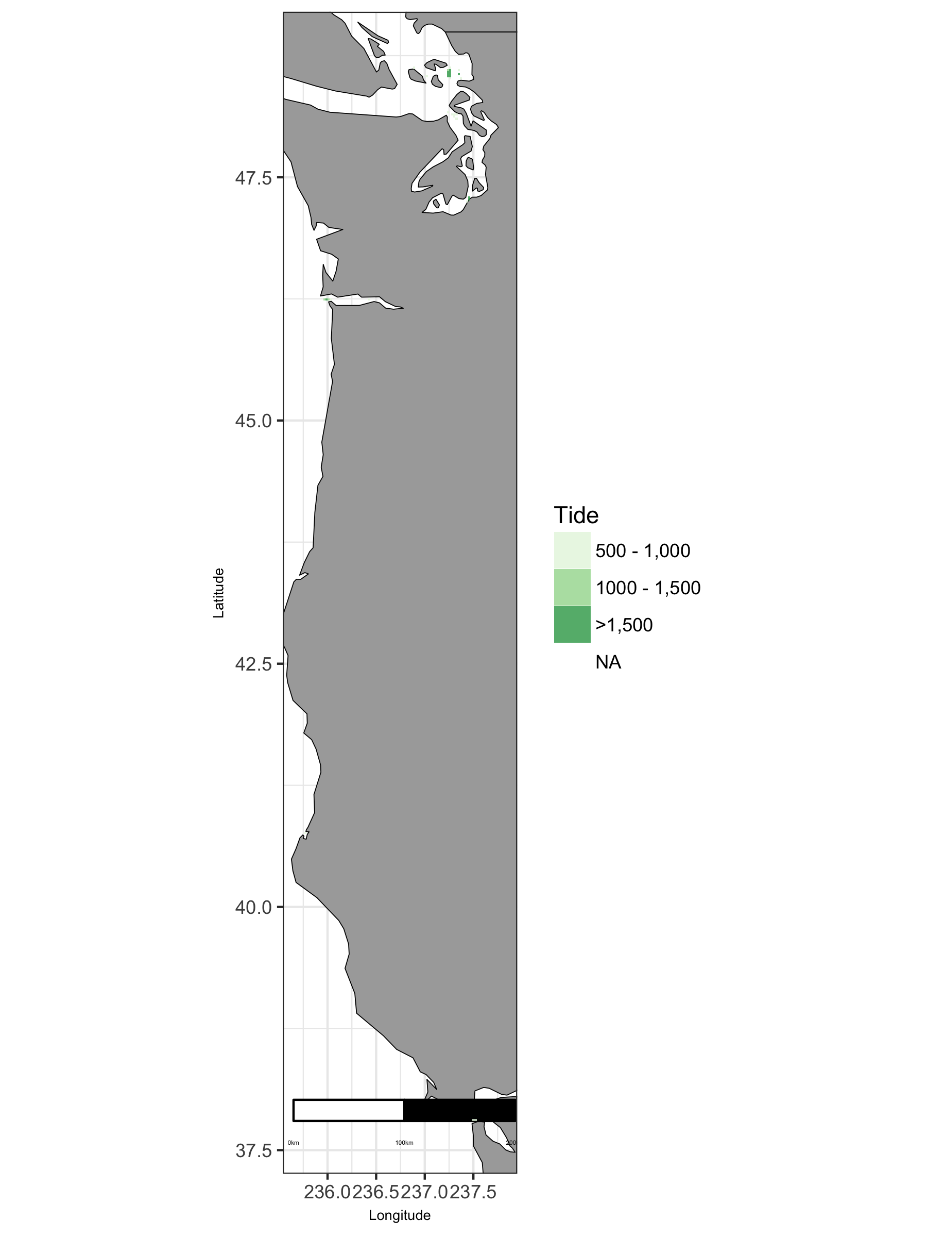

Map of viable tide in West region.

### West: Plot of Uses by Tide

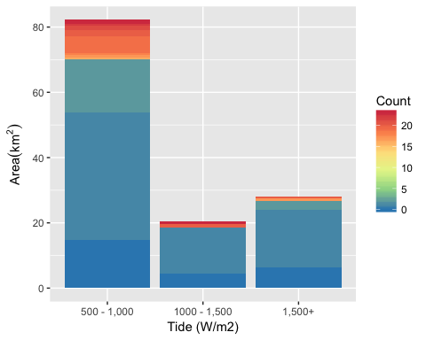

Area of Cumulative Ocean Use by Tide (W/m2) for West region. Cumulative use are counted and summarized by Tide (W/m2) and area.

### West: Table of Uses by Tide

Table 20: Area (km2) of ocean use layers by tide (W/m2) bin for West region. Layers are grouped by dataset. The total area considered was limited to maximum depth of 100 m and minimum tide of Inf W/m2. The layer’s bar graph shows percent total coverage for considered area.

|  |  |  |  |  |  |  |
| --- | --- | --- | --- | --- | --- | --- |
| **Dataset**, Layer |  | % | 500 - 1,000 | 1000 - 1,500 | 1,500+ | Total |
| **Total Area** |  | 100 | 82 | 20 | 28 | 131 |
| **Essential Fish Habitat** |  |  |  |  |  |  |
| Estuaries |  | 45 | 42 | 10 | 7 | 59 |
| Groundfish |  | 1 | 1 |  |  | 1 |
| Seagrass |  | 1 |  | 1 | 1 | 1 |
| **Marine Protected Areas** |  |  |  |  |  |  |
| National Marine Sanctuaries |  | 2 | 1 | 1 |  | 2 |
| National Park Service |  | 1 | 1 |  |  | 1 |
| National Wildlife Refuge System |  | 2 | 2 |  |  | 2 |
| State MPA |  | 22 | 15 | 3 | 11 | 29 |
| **Ocean Use Atlas for California** |  |  |  |  |  |  |
| Alt Energy Future |  | 4 | 5 |  |  | 5 |
| Aquaculture |  | 1 | 1 | 1 |  | 1 |
| Beach |  | 6 | 7 | 1 | 1 | 8 |
| Com Benthic Fixed |  | 7 | 8 | 1 | 1 | 9 |
| Com Dive |  | 1 | 1 | 1 |  | 1 |
| Com Pelagic |  | 7 | 8 | 1 | 1 | 9 |
| Hunting |  | 3 | 3 | 1 | 1 | 4 |
| Kayak Fishing |  | 7 | 8 | 1 | 1 | 9 |
| Military |  | 7 | 7 | 1 | 1 | 9 |
| Mining |  | 1 | 1 |  |  | 1 |
| Motorized Boating |  | 7 | 8 | 1 | 1 | 9 |
| Oil |  | 5 | 6 |  |  | 6 |
| Paddling |  | 7 | 8 | 1 | 1 | 9 |
| Rec Boat |  | 7 | 8 | 1 | 1 | 9 |
| Rec Dive |  | 7 | 8 | 1 | 1 | 9 |
| Rec Shore Harvest |  | 6 | 7 | 1 | 1 | 8 |
| Sailing |  | 7 | 8 | 1 | 1 | 9 |
| Scuba |  | 3 | 3 | 1 |  | 3 |
| Shipping |  | 5 | 7 |  |  | 7 |
| Shore Fishing |  | 6 | 7 | 1 | 1 | 8 |
| Surface Sports |  | 6 | 7 | 1 | 1 | 8 |
| Swimming |  | 2 | 1 | 1 |  | 2 |
| Tidepooling |  | 5 | 6 | 1 |  | 7 |
| Wildlife Viewing |  | 7 | 8 | 1 | 1 | 9 |
| **Ocean Use Atlas for Oregon & Washington** |  |  |  |  |  |  |
| Aquaculture |  | 1 | 1 |  |  | 1 |
| Com Fishing Fixed |  | 5 | 4 | 1 | 1 | 6 |
| Com Fishing Mobile |  | 5 | 4 | 1 | 1 | 6 |
| Com Pelagic Fishing |  | 5 | 4 | 1 | 1 | 6 |
| Cruise Ships |  | 4 | 4 | 1 | 1 | 5 |
| Cultural Use |  | 5 | 4 | 1 | 1 | 6 |
| Fishing Shore |  | 1 | 1 |  |  | 1 |
| Hunting |  | 5 | 4 | 1 | 1 | 6 |
| Marine Debris |  | 0 | 1 |  |  | 1 |
| Military Operations |  | 5 | 4 | 1 | 1 | 6 |
| Mining Mineral Ext |  | 5 | 4 | 1 | 1 | 6 |
| Motorized Boating |  | 5 | 4 | 1 | 1 | 6 |
| Ocean Dumping |  | 1 | 2 |  |  | 2 |
| Paddling |  | 5 | 4 | 1 | 1 | 6 |
| Perm Research Areas |  | 5 | 4 | 1 | 1 | 6 |
| Rec Dive Fishing |  | 5 | 4 | 1 | 1 | 6 |
| Rec Fishing Ben Boats |  | 5 | 4 | 1 | 1 | 6 |
| Rec Fishing Pel Boats |  | 5 | 4 | 1 | 1 | 6 |
| Rec Gathering Shore |  | 1 | 1 |  |  | 1 |
| Sailing |  | 5 | 4 | 1 | 1 | 6 |
| Shipping |  | 5 | 4 | 1 | 1 | 6 |
| Surface Board Sports |  | 5 | 4 | 1 | 1 | 6 |
| Swimming |  | 4 | 4 | 1 | 1 | 5 |
| Tide Pooling |  | 0 | 1 |  |  | 1 |
| Wildlife Viewing Sea |  | 5 | 4 | 1 | 1 | 6 |
| **Shipping Lanes** |  |  |  |  |  |  |
| Shipping Lanes |  | 24 | 23 | 2 | 7 | 32 |

### West: Map of Wave

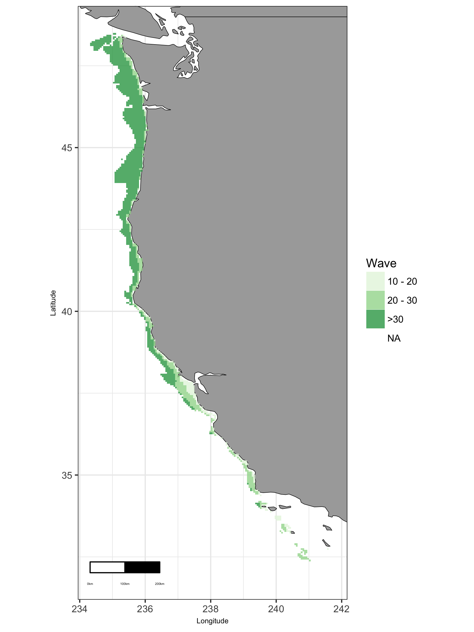

Map of viable wave in West region.

### West: Plot of Uses by Wave

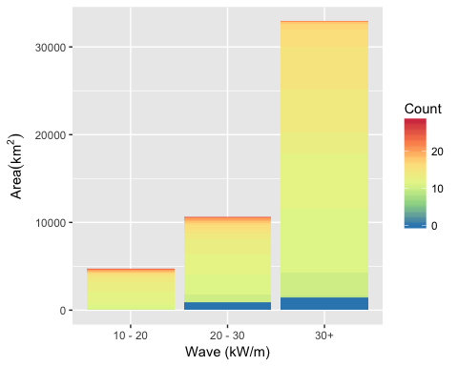

Area of Cumulative Ocean Use by Wave (kW/m) for West region. Cumulative use are counted and summarized by Wave (kW/m) and area.

### West: Table of Uses by Wave

Table 21: Area (km2) of ocean use layers by wave (kW/m) bin for West region. Layers are grouped by dataset. The total area considered was limited to maximum depth of 200 m and minimum wave of Inf kW/m. The layer’s bar graph shows percent total coverage for considered area.

|  |  |  |  |  |  |  |
| --- | --- | --- | --- | --- | --- | --- |
| **Dataset**, Layer |  | % | 10 - 20 | 20 - 30 | 30+ | Total |
| **Total Area** |  | 100 | 4,680 | 10,608 | 32,910 | 48,199 |
| **Active Oil & Gas Leases** |  |  |  |  |  |  |
| Active Oil & Gas Leases |  | 0 |  | 128 | 13 | 140 |
| **Aquaculture** |  |  |  |  |  |  |
| Shellfish |  | 0 | 1 |  |  | 1 |
| **Essential Fish Habitat** |  |  |  |  |  |  |
| Canopy Kelp |  | 1 | 271 | 156 | 18 | 445 |
| Estuaries |  | 0 | 7 | 33 |  | 40 |
| Groundfish |  | 5 | 172 | 1,284 | 902 | 2,358 |
| Rocky Reefs |  | 8 | 348 | 997 | 2,334 | 3,680 |
| Seagrass |  | 0 | 2 | 14 |  | 16 |
| **Marine Protected Areas** |  |  |  |  |  |  |
| National Marine Fisheries Service |  | 10 | 391 | 1,742 | 2,872 | 5,004 |
| National Marine Sanctuaries |  | 31 | 2,463 | 4,399 | 7,884 | 14,745 |
| National Park Service |  | 0 | 51 | 18 |  | 69 |
| State MPA |  | 4 | 616 | 888 | 238 | 1,742 |
| **Ocean Use Atlas for California** |  |  |  |  |  |  |
| Alt Energy Future |  | 26 | 1,861 | 4,289 | 6,429 | 12,578 |
| Aquaculture |  | 0 | 20 |  |  | 20 |
| Beach |  | 1 | 323 | 206 | 8 | 537 |
| Cables |  | 4 | 485 | 735 | 640 | 1,861 |
| Com Benthic Fixed |  | 41 | 4,311 | 8,150 | 7,319 | 19,780 |
| Com Benthic Mobile |  | 29 | 2,494 | 5,634 | 5,937 | 14,065 |
| Com Dive |  | 2 | 557 | 492 | 65 | 1,114 |
| Com Kelp |  | 2 | 384 | 399 | 73 | 857 |
| Com Pelagic |  | 41 | 4,392 | 8,158 | 7,022 | 19,572 |
| Hunting |  | 5 | 942 | 1,449 | 158 | 2,549 |
| Kayak Fishing |  | 17 | 2,666 | 3,711 | 1,936 | 8,313 |
| Military |  | 42 | 4,497 | 8,453 | 7,453 | 20,404 |
| Mining |  | 0 | 39 | 11 |  | 50 |
| Motorized Boating |  | 42 | 4,497 | 8,453 | 7,453 | 20,404 |
| Oil |  | 33 | 2,552 | 6,526 | 6,957 | 16,035 |
| Paddling |  | 16 | 2,775 | 3,512 | 1,322 | 7,609 |
| Rec Boat |  | 41 | 4,399 | 8,257 | 7,319 | 19,976 |
| Rec Dive |  | 11 | 2,698 | 2,065 | 438 | 5,201 |
| Rec Shore Harvest |  | 6 | 1,173 | 1,551 | 166 | 2,891 |
| Sailing |  | 42 | 4,497 | 8,453 | 7,453 | 20,404 |
| Scuba |  | 5 | 1,068 | 1,046 | 280 | 2,393 |
| Shipping |  | 22 | 1,662 | 4,537 | 4,192 | 10,391 |
| Shore Fishing |  | 1 | 332 | 224 | 10 | 567 |
| Surface Sports |  | 6 | 1,482 | 1,030 | 172 | 2,684 |
| Swimming |  | 1 | 286 | 114 |  | 400 |
| Tidepooling |  | 1 | 295 | 163 | 6 | 463 |
| Wildlife Viewing |  | 40 | 4,286 | 7,800 | 7,373 | 19,459 |
| **Ocean Use Atlas for Oregon & Washington** |  |  |  |  |  |  |
| Aquaculture |  | 0 | 2 |  |  | 2 |
| Com Dive Fishing |  | 0 | 16 | 2 |  | 18 |
| Com Fishing Fixed |  | 53 | 149 | 1,289 | 23,995 | 25,433 |
| Com Fishing Mobile |  | 53 | 149 | 1,289 | 23,995 | 25,433 |
| Com Gathering Shore |  | 0 | 2 | 42 |  | 44 |
| Com Pelagic Fishing |  | 53 | 149 | 1,289 | 23,995 | 25,433 |
| Cruise Ships |  | 20 | 29 | 24 | 9,678 | 9,731 |
| Cultural Use |  | 53 | 149 | 1,289 | 23,995 | 25,433 |
| Fishing Shore |  | 0 | 16 | 63 | 1 | 80 |
| Hunting |  | 25 | 144 | 1,210 | 10,503 | 11,857 |
| Kayak Fishing |  | 1 | 95 | 341 | 101 | 536 |
| Marine Debris |  | 3 | 58 | 377 | 1,170 | 1,605 |
| Military Operations |  | 53 | 149 | 1,289 | 23,995 | 25,433 |
| Mining Mineral Ext |  | 1 | 34 | 152 | 63 | 249 |
| Motorized Boating |  | 52 | 149 | 1,289 | 23,394 | 24,831 |
| Ocean Dumping |  | 25 | 6 | 299 | 11,719 | 12,024 |
| Offshore Alt Energy |  | 1 | 2 | 49 | 268 | 319 |
| Paddling |  | 2 | 134 | 683 | 142 | 959 |
| Perm Research Areas |  | 34 | 144 | 1,212 | 15,042 | 16,398 |
| Rec Dive Fishing |  | 3 | 60 | 666 | 554 | 1,280 |
| Rec Fishing Ben Boats |  | 53 | 149 | 1,289 | 23,995 | 25,433 |
| Rec Fishing Pel Boats |  | 53 | 149 | 1,289 | 23,995 | 25,433 |
| Rec Gathering Shore |  | 0 | 23 | 75 | 1 | 99 |
| Sailing |  | 53 | 149 | 1,289 | 23,995 | 25,433 |
| Scuba Snorkeling |  | 3 | 52 | 662 | 541 | 1,254 |
| Shipping |  | 46 | 109 | 451 | 21,654 | 22,214 |
| Shore Use |  | 0 | 15 | 59 | 1 | 74 |
| Surface Board Sports |  | 1 | 92 | 396 | 28 | 517 |
| Swimming |  | 1 | 92 | 396 | 28 | 516 |
| Tide Pooling |  | 0 | 21 | 61 | 1 | 83 |
| Underwater Cables |  | 5 | 50 | 113 | 2,282 | 2,444 |
| Wildlife Viewing Sea |  | 45 | 149 | 1,289 | 20,303 | 21,741 |
| **Shipping Lanes** |  |  |  |  |  |  |
| Shipping Lanes |  | 1 | 112 | 252 | 174 | 538 |

### West: Map of Wind

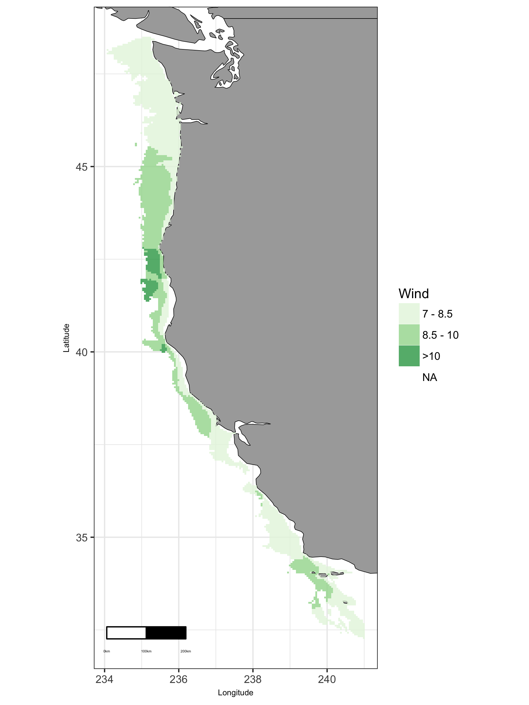

Map of viable wind in West region.

### West: Plot of Uses by Wind

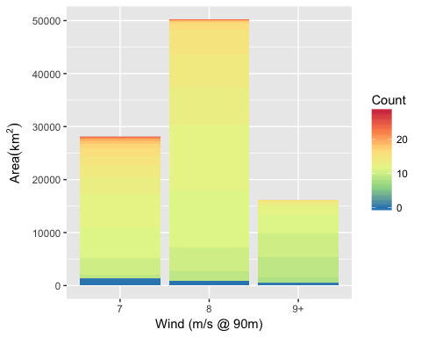

Area of Cumulative Ocean Use by Wind (m/s @ 90m) for West region. Cumulative use are counted and summarized by Wind (m/s @ 90m) and area.

### West: Table of Uses by Wind

Table 22: Area (km2) of ocean use layers by wind (m/s) bin for West region. Layers are grouped by dataset. The total area considered was limited to maximum depth of 1000 m and minimum wind of Inf m/s. The layer’s bar graph shows percent total coverage for considered area.

|  |  |  |  |  |  |  |
| --- | --- | --- | --- | --- | --- | --- |
| **Dataset**, Layer |  | % | 7 | 8 | 9+ | Total |
| **Total Area** |  | 100 | 28,051 | 50,169 | 16,137 | 94,357 |
| **Active Oil & Gas Leases** |  |  |  |  |  |  |
| Active Oil & Gas Leases |  | 0 | 153 | 73 |  | 226 |
| **Essential Fish Habitat** |  |  |  |  |  |  |
| Canopy Kelp |  | 0 | 116 | 40 | 11 | 167 |
| Estuaries |  | 0 | 387 |  |  | 387 |
| Groundfish |  | 4 | 2,057 | 1,286 | 11 | 3,353 |
| Rocky Reefs |  | 7 | 2,366 | 3,443 | 1,171 | 6,981 |
| Seagrass |  | 0 | 106 |  |  | 106 |
| **Marine Protected Areas** |  |  |  |  |  |  |
| National Marine Fisheries Service |  | 15 | 5,912 | 7,231 | 683 | 13,826 |
| National Marine Sanctuaries |  | 21 | 11,629 | 7,768 | 236 | 19,634 |
| National Park Service |  | 0 | 139 | 129 | 6 | 274 |
| National Wildlife Refuge System |  | 0 | 4 |  |  | 4 |
| State MPA |  | 2 | 913 | 1,030 | 64 | 2,008 |
| **Ocean Use Atlas for California** |  |  |  |  |  |  |
| Alt Energy Future |  | 17 | 6,728 | 8,274 | 1,460 | 16,462 |
| Aquaculture |  | 0 | 24 |  |  | 24 |
| Beach |  | 0 | 186 | 89 | 3 | 278 |
| Cables |  | 7 | 4,590 | 2,377 | 39 | 7,007 |
| Com Benthic Fixed |  | 48 | 19,820 | 17,694 | 7,824 | 45,338 |
| Com Benthic Mobile |  | 37 | 13,658 | 14,400 | 6,911 | 34,969 |
| Com Dive |  | 1 | 711 | 344 | 22 | 1,077 |
| Com Kelp |  | 0 | 112 | 5 | 8 | 125 |
| Com Pelagic |  | 50 | 20,014 | 19,404 | 7,821 | 47,239 |
| Hunting |  | 16 | 6,530 | 8,356 | 545 | 15,431 |
| Kayak Fishing |  | 5 | 2,858 | 1,542 | 283 | 4,682 |
| Military |  | 51 | 20,234 | 19,945 | 7,839 | 48,018 |
| Mining |  | 0 | 32 |  |  | 32 |
| Motorized Boating |  | 51 | 20,234 | 19,945 | 7,839 | 48,018 |
| Oil |  | 49 | 19,051 | 19,378 | 7,782 | 46,211 |
| Paddling |  | 5 | 2,699 | 1,728 | 303 | 4,730 |
| Rec Boat |  | 50 | 20,131 | 19,480 | 7,824 | 47,435 |
| Rec Dive |  | 4 | 2,459 | 839 | 37 | 3,335 |
| Rec Shore Harvest |  | 16 | 6,606 | 8,363 | 546 | 15,515 |
| Sailing |  | 51 | 20,234 | 19,945 | 7,807 | 47,986 |
| Scuba |  | 2 | 947 | 830 | 22 | 1,798 |
| Shipping |  | 40 | 17,051 | 16,903 | 4,098 | 38,052 |
| Shore Fishing |  | 0 | 171 | 27 | 1 | 199 |
| Surface Sports |  | 2 | 1,052 | 483 | 13 | 1,548 |
| Swimming |  | 0 | 57 | 15 |  | 72 |
| Tidepooling |  | 0 | 172 | 67 | 3 | 242 |
| Wildlife Viewing |  | 41 | 16,080 | 16,206 | 6,539 | 38,826 |
| **Ocean Use Atlas for Oregon & Washington** |  |  |  |  |  |  |
| Aquaculture |  | 0 | 266 |  |  | 266 |
| Com Dive Fishing |  | 0 | 1 |  |  | 1 |
| Com Fishing Fixed |  | 46 | 6,437 | 29,299 | 7,818 | 43,554 |
| Com Fishing Mobile |  | 46 | 6,437 | 29,262 | 7,818 | 43,517 |
| Com Gathering Shore |  | 0 | 237 |  |  | 237 |
| Com Pelagic Fishing |  | 46 | 6,437 | 29,299 | 7,818 | 43,554 |
| Cruise Ships |  | 24 | 1,335 | 18,229 | 3,359 | 22,923 |
| Cultural Use |  | 46 | 6,437 | 29,299 | 7,818 | 43,554 |
| Fishing Shore |  | 0 | 86 | 1 |  | 86 |
| Hunting |  | 19 | 6,026 | 11,924 |  | 17,950 |
| Kayak Fishing |  | 1 | 470 | 6 |  | 476 |
| Marine Debris |  | 2 | 791 | 831 |  | 1,622 |
| Military Operations |  | 46 | 6,437 | 29,299 | 7,818 | 43,554 |
| Mining Mineral Ext |  | 1 | 478 | 55 |  | 533 |
| Motorized Boating |  | 35 | 5,820 | 23,256 | 3,932 | 33,008 |
| Ocean Dumping |  | 26 | 4,698 | 18,420 | 1,268 | 24,386 |
| Offshore Alt Energy |  | 0 | 80 | 238 | 58 | 377 |
| Paddling |  | 1 | 930 | 54 |  | 984 |
| Perm Research Areas |  | 26 | 6,029 | 17,212 | 830 | 24,071 |
| Rec Dive Fishing |  | 1 | 1,012 | 20 |  | 1,032 |
| Rec Fishing Ben Boats |  | 42 | 6,437 | 25,983 | 7,189 | 39,609 |
| Rec Fishing Pel Boats |  | 46 | 6,437 | 29,299 | 7,818 | 43,554 |
| Rec Gathering Shore |  | 0 | 125 | 1 |  | 126 |
| Sailing |  | 46 | 6,437 | 29,299 | 7,818 | 43,554 |
| Scuba Snorkeling |  | 1 | 962 |  |  | 962 |
| Shipping |  | 43 | 3,612 | 29,037 | 7,818 | 40,467 |
| Shore Use |  | 0 | 79 | 1 |  | 79 |
| Surface Board Sports |  | 0 | 451 | 13 |  | 464 |
| Swimming |  | 0 | 393 | 13 |  | 406 |
| Tide Pooling |  | 0 | 118 | 1 |  | 119 |
| Underwater Cables |  | 5 | 964 | 2,759 | 541 | 4,264 |
| Underwater Pipelines |  | 0 | 1 |  |  | 1 |
| Wildlife Viewing Sea |  | 29 | 6,094 | 17,106 | 4,350 | 27,550 |
| **Shipping Lanes** |  |  |  |  |  |  |
| Shipping Lanes |  | 1 | 493 | 411 |  | 904 |